Betting Against Beta Beyond 2012

Applied Finance Project

Master of Financial Engineering

Haas School of Business, UC Berkeley

March 3rd, 2021

Advisors

Dr. Amir Kermani

Dr. Eric Reiner

Submitted By:

Bolun Deng

Yanggang Fang

Jinyang Li

Hexin Xu

Zhanqi Yang

This page is left blank intentionally.

**Acknowledgment**

**Abstract**

Historically, many empirical studies have shown that real-world returns deviate from CAPM significantly. Since Black(1972) firstly brought up the point that the risk-adjusted returns of low beta stocks are relatively high compared to high-beta stock, subsequent findings support the asymmetric pattern in returns, which yields a flatter security market line. Many researchers attribute the phenomenon to restricted borrowing and leverage constraints that lead to overweighting on high-beta securities. In spite of a variety of theories to explain, a natural strategy that takes advantage of the flat market line populates, which constructs a portfolio of longing low-beta securities and financed by shorting low-beta ones. In this report, we test the performance and effectiveness of the so-called Betting against Beta strategy. Specifically, we mainly refer to the paper Betting Against Beta (Frazzini and Pedersen, 2014), where the authors claim that such BAB factor yields ‘highly significant risk-adjusted returns’. We first replicate the paper by constructing 10 equal-weighted portfolios from beta ranking and a BAB portfolio that longs low-beta stocks and shorts high-beta ones. The BAB portfolio is daily rebalanced and beta-weighted. Our results show that portfolios with higher beta have bad performance and BAB achieves significant alpha, which are in accordance with the paper. We then extend the strategy to recent years, especially including the Covid-19 periods, and the results support the consistency and robustness of the strategy. Given the evidence from Blitz, Pang, and Vliet (2014) who found a flat SML in emerging equity markets, we apply the BAB factor to China’s A-share market.

**Keywords:** betting against beta, BAB factor, SML, CAPM, leverage constraints, China’s A-share market

Table of Contents

**Introduction** **5**

Background Introduction 5

Literature Review 6

Problem Definition 9

**Data and Methodology** **10**

Data Description and Sources 10

US Equities Data 10

China’s A-share Data 11

Methodology 12

Ex-ante Beta Estimation 12

BAB Factor Construction 13

**Validation and Extension of the Original Paper** **14**

Validation using US Equity Market Data 2008 - 2012 14

Over the Whole Period (2008 - 2020) 15

Visualization and Analysis 16

Over the Expansion Period (2009 - 2019) 21

Post-GFC (2009 - 2020) 21

BAB factor validation 22

Extension to China’s A-share Market 24

Over the Whole Period (2008 - 2020) 24

Over the Expansion Period (2009 - 2019) 33

Post-GFC (2009 - 2020) 34

Comparison with the US Equity Market 34

**Strategy Back-testing Results** **35**

Over the Whole Period (2008-2020) 35

Post-GFC (2014-2020) 37

**Conclusion** **38**

**Future Work** **40**

**Bibliography** **40**

**Appendix** **42**

Cumulative Excess Returns for HML and CMA factors in China market 42

Visualization of table x for the Chinese market 43

Cumulative Excess Returns for single factor in US market 43

# **Introduction**

## **Background Introduction**

Under the capital asset pricing model (CAPM), an important premise is that all investors leverage or de-leverage the market portfolio to meet their risk preferences and generate the highest Sharpe ratio (Treynor, 1962; Sharpe, 1964). In reality, however, many investors (e.g. pension funds, mutual funds, etc.) are constrained in the leverage they are able to take, which results in a tendency to overweight risky securities.

In the paper Betting Against Beta (Frazzini and Pedersen, 2014), the authors proposed a dynamic model with leverage constraints along with five predictions and then found evidence on each of them. The first proposition is that high beta is consistently correlated with low alpha, which is validated through the flatness of the security market line[1] not only in the U.S. and 18 out of 19 international equities markets, but also in multiple asset classes.

The second and major proposition includes an introduction of a market-neutral “betting against beta (BAB)” factor, which is defined as a portfolio that both longs leveraged low-beta assets and shorts de-leveraged high-beta assets to a beta of 1. The authors found that the BAB portfolio was able to generate “highly significant risk-adjusted returns” across different countries and asset classes.

As shown in the paper, U.S. BAB factor was able to realize a Sharpe ratio of 0.78 in the period between 1926 and 2012, which is much higher than the value effect ($SR^{HML}=0.39$) and momentum ($SR^{UMD} = 0.50$). Similar results are discovered using data of 19 other developed MSCI stock markets. Apart from the US stock markets, the BAB factor produced superior risk-adjusted returns in US Treasuries[2] and credit markets[3].

In the paper, the evidence shows consistent abnormal BAB returns across countries, time, and asset classes, even within different deciles by size and idiosyncratic risk. The authors believe that a plausible explanation is that investors who have leverage constraints tend to overweight riskier stocks in their portfolios in order to obtain a higher expected return than the market. As a result, the risk-adjusted returns on stocks with low-beta will rise and the returns on high-beta stocks will decrease.

Leverage-constrained investors who, instead of applying leverage, obtain an expected return higher than the market’s expected return through overweighting high-beta stocks in their portfolios. Their actions lower future risk-adjusted returns on high-beta stocks and increase future risk-adjusted returns on low-beta stocks.

## **Literature Review**

The BAB factor explores and sheds light on an updated version of the relation between risk and expected returns. This central issue in financial economics has naturally received much attention, as well as challenges.

Since the 1970s, many studies have suggested that the returns on securities do not behave as the simple CAPM described above predicts they should. Both Pratt (1967) and Friend and Blume (1970) have concluded that the high-risk portfolios seem to have poor performance on the level that they did not give the extra returns on the horizon of 1926-1968 as the theory predicted. Black, Jensen, and Scholes (1972) firstly put forward the argument that the risk-adjusted returns of high beta stocks are too low relative to low-beta stock, resulting in a security market line that is too flat. The finding was later confirmed by Fama and French (1992) in an influential study. Beyond the US market, evidence of the consistent beta anomaly was also found in both non-US developed markets and emerging markets by Blitz and van Vliet (2007), Blitz, Pang, and van Vliet (2013), Baker, Bradley, and Taliaferro (2014) and Frazzini and Pedersen (2014).

A variety of explanations have been offered to explain the existence of this divergence from CAPM. The first and perhaps the most obvious explanation is that some investors tend to hold a high-risk high-return portfolio yet are reluctant or limited to take leverage. Black (1972) challenged the CAPM assumption of freely borrowing and lending and explored a market equilibrium under restricted borrowing. Gibbons (1982), Kandel (1984), and Shanken (1985) suggested that the constrained-borrowing CAPM has a better fit. A more frequent study was conducted by Frazzini and Pedersen (2014). The authors argued that investors with leverage constraints are likely to diverge from the security market line (SML) as they invest in securities with high beta in an attempt to gain higher expected returns. Thus, these high-beta stocks have the tendency to be overpriced relative to the benchmark of CAPM. Jylhä (2017) provided evidence with Federal Reserve changes in initial margin requirements to support this argument. Similarly, Karceski (2002), Baker, Bradley, and Wurgler (2011) and Buffa, Vayanos, and Woolley (2014) used institutional investors' benchmarking to explain this interpretation, and Koijen and Yogo (2017) proposed an applicable framework that can be used to model the role of institutions in asset markets.

There also exist other points of view in explaining the anomaly. Karceski (2002) suggested an agency-level explanation for the imbalance in beta premium - traditional mutual funds long-only managers prefer high-beta and dislike low-beta stocks in order to attract significant inflow during bull markets. Other explanations involve irrational traders who overweight high-beta stocks and their sentiment affects the market as a whole, resulting in an overvaluation of those assets. Liu, Stambaugh, and Yuan (2017) attributed the beta anomaly to the positive correlation between market beta and idiosyncratic volatilities.

Taking advantage of better (worse) performance of low-beta (high-beta) assets relative to market return, or, to put it another way, the flatter SML caused by constraints over CAPM, the beta-arbitrage idea originated by Black (1972) has drawn wide attention and been explored over time. Frazzini and Pedersen (2014) documented that a betting-against-beta strategy that takes long positions in low-beta stocks and short positions in high-beta stocks generates a large abnormal return of 6.6% per year and they attributed this phenomenon to funding liquidity risk. Bali, Brown, May, and Tang (2014) demonstrated that price pressure driven by demand for lottery-like stocks played a significant role in generating the betting against beta phenomenon and their lottery-demand factor explained the abnormal returns of the BAB factor. Meanwhile, Marx and Velicov (2018) challenged the effectiveness of the BAB factor by highlighting that the non-standard, non-transparent procedures taken by the paper plays an important role in generating its strong results.

Finally, Blitz, Pang and Vliet (2014) examined the empirical relation between risk and return in emerging equity markets and found a flat or even negative-sloped SML. The result lays the foundation for betting against beta strategy and motivates us to test the BAB factor in emerging markets in our work.

## **Problem Definition**

As introduced earlier, the original paper Betting Against Beta raises five propositions and validates them with the study on equities, TED spread data, and equity portfolios of mutual funds and individual investors. In this project, we will concentrate only on the US and international stock markets. Therefore, there are two hypotheses[4] that we plan to test and verify, which can be accomplished using equity data. The first and most essential hypothesis is that high beta comes with low alpha due to the fact that constrained investors tend to bid up high-beta assets. The other hypothesis is that using a BAB factor[5] can generate a significant positive risk-adjusted return.

We will begin with the replication and validation of the conclusions mentioned in the original paper regarding the US equity market, as well as the 19 other developed MSCI stock markets. Then, following the work done in Blitz, Pang, and Vliet (2014), we will conduct a more comprehensive analysis regarding the emerging markets[6]. More specifically, we will test the feasibility of whether one can time BAB strategy both in developed markets and in developing markets. We will also compare the similarities and differences of the effectiveness of the BAB strategy and try to explain the underlying reasons.

The original paper uses US equity data from 1926 to 2012, and international equities data from 1984 to 2012. However, since 2012, the market has experienced a long bull market and a massive drawdown in early 2020 due to COVID-19. Also, between 2015 and 2016, the Chinese stock market experienced severe turbulence. For the Shanghai Stock Exchange alone, one-third of the value of A-shares evaporated within a month, and 50% of the listed companies (1400 companies) filed for a trading halt to control their damage. Therefore, it is worthwhile exploring the effectiveness and feasibility of the BAB strategy beyond 2012. We plan to extend both our analysis on the US equities market and China’s A-share market starting from 2012 to 2020 and explain the potential causes for the changes over time and differences between the two countries.

The paper is organized as follows. Section 1 includes a summarization of relevant literature and defines the hypotheses we intend to test. Section 2 describes our data source and empirical methodology to estimate beta and construct the BAB factor. In section 3, we start with replication and extension of the paper to construct the US equity BAB factor from 2005 to 2020 and analyze the BAB portfolio performance with multiple metrics. Then, we investigate the strategy effectiveness in emerging markets, specifically in the China A-share market. We also examine four BAB trading strategies profitability and performance utilizing both the Chinese market’s BAB factor and the US market’s BAB factor. Section 5 includes our findings and conclusion.

# **Data and Methodology**

## **Data Description and Sources**

In this project, we focus on the US equity market and China’s A-share market with data collected from multiple sources.

### **US Equities Data**

Our daily US equity return data is collected from the Center for Research in Security Prices (CRSP) database from 2005 to 2020. The dataset includes end-of-day historical data on 8984 stocks primarily listed on NYSE, NYSE MKT, NASDAQ and Arca exchanges. We use the daily CRSP value-weighted market index[7] as the proxy for the US equity market factor and collect the data from 2005 to 2020 on CRSP. For factor analysis, we take daily factor returns data including size (small minus big, SMB), book-to-market (high minus low, HML), momentum (up minus down, UMD) directly from AQR’s data library[8] from 1926 to 2020[9]. For risk-free rate, we use the 1-month T-bill as in the original paper. The daily BAB factor data on the US equity market is also available on AQR’s data library from 1930 to 2020, but we will calculate and replicate the BAB factor by ourselves as the first step of this project and only use this provided dataset as a reference.

### **China’s A-share Data**

The daily equity return data in China’s A-share market is obtained from JointQuant database from 2005 to 2020 including 3529 stocks listed in Shanghai Stock Exchange and Shenzhen Stock Exchange excluding all the shares marked with “ST (Special Treatment)”[10]. The CSI all-share index is used as the proxy for China’s A-share market factor, and the dataset is collected from Wind. In order to conduct sector analysis and observe the effectiveness of BAB factor in different industries, we also collect the data regarding the industrial classification (based on industry code) for equities in China’s A-share market from JoinQuant Data. For factor analysis, we obtain the Fama-French 3-factor and 5-factor data from CSMAR whose research team has strictly adhered to the methodology that Fama and French used in their original papers according to the dataset description on CSMAR. Notice that the five factors contained in the dataset are different from the ones used for the US Equity market. The factors include market risk premium, size (small minus big, SMB), book-to-market (high minus low, HML), profitability (high-profitable minus low-profitable, RMW), and investment pattern (conservative minus aggressive, CMA). For the risk-free rate, we use the 1-year LCY Government Bond Yield[11]. The time range of factor data both daily and monthly covers the period from 2005 to 2020.

## **Methodology**

In this section, we mainly discuss the procedure to estimate betas, to construct the BAB factor and to implement the BAB strategy.

### **Ex-ante Beta Estimation**

We perform ex-ante beta estimation by conducting rolling regressions of each individual security’s excess returns on market excess returns. The formula of estimated beta is given by:

$\hat{β_{i}}=\hat{ρ}\frac{{\hat{σ}}_{i}}{{\hat{σ}}_{m}}$.

In order to estimate beta, we follow the original paper to estimate volatilities for the individual stock and the market and their correlation separately.

For correlation estimation, we use overlapping three-day log-returns

$${r^{3-day}}_{i,t}=\sum_{k=0}^{2}{}ln(1+{r^{i}}_{t+k})$$

and a rolling horizon of five years (with at least 750 trading days of non-missing data)[12]. On the contrary, for the estimation of stock and market volatilities, we use one-day log-returns followed by a rolling standard deviation of one year (with at least 120 trading days of non-missing data) as the estimated volatilities. The reason for the different rolling horizon is to eliminate the effect that correlations are likely to move more slowly than volatilities historically, and the different log-returns used is to control non-synchronous trading that affects the correlations significantly.

Moreover, we shrink the time series estimation of individual beta using the following formula:

$$\hat{β_{i}}=w_{i}{{\hat{β}}_{i}}^{TS}+(1-w_{i}){{\hat{β}}_{i}}^{XS}$$

with the assumption that $w=0.6$ and $β^{XS}=1$ (cross-sectional beta) across all assets in all periods. The reason for this step of shrinkage is to reduce the effect of outliers.

### **BAB Factor Construction**

As introduced earlier, the BAB is a simple zero-beta self-financing portfolio that longs the leveraged low-beta portfolio (to a beta of 1) and shorts the de-leveraged high-beta Portfolio (to a beta of 1):

${r_{t+1}}^{BAB}=\frac{1}{{β^{L}}_{t}}({r^{L}}_{t+1}-r_{f})-\frac{1}{{β^{H}}_{t}}({r^{H}}_{t+1}-r_{f})$.

Firstly, we rank all the individual stocks by their estimated beta values and remove those with negative beta as they are not in our investment universe. For example, the gold ETF has a negative correlation with the equity market but typically it is not for investment purposes, but for the use of hedging. Therefore, it has nothing to do with limited borrowing or leverage constraints that drive investors to overweight high-beta portfolios according to the paper. We also remove the bad tickers with unrealistic returns. For instance, some stocks have over 100% return which is not possible as one stock can drop at most 100% to 0; some stocks have over -99% return for the time horizon with extremely low liquidity. Such stocks are not within our universe either. After removing those bad tickers, we involve 7363 stocks in total.

To study the relationship between return and beta, we construct ten beta-sorted portfolios: P1 to P10 from low beta to high beta. The portfolios are equal-weighted and rebalanced every day. As the paper proposed, accuracy will be improved if rebalanced on a daily basis. Using time-series returns for each portfolio, we estimate alpha based on the CAPM model and the Fama-French factor models. We match with factor data and run time-series regressions to calculate alpha, beta, volatility as well as the Sharpe ratio for each portfolio.

To construct the daily rebalanced BAB factor, we rank all securities based on their estimated beta and assign them to one of the two portfolios: high-beta and low-beta. The low-beta(high-beta) portfolio then contains half of the universe stocks with a beta lower(higher) than the median. Within each portfolio, the stocks are beta-weighted. In other words, for the low-beta portfolio, lower beta implies larger weight assigned to the stock; while for the high-beta portfolio, higher beta indicates larger weight assigned to the stock. Every day we long the low-beta portfolio and leverage the position to have a beta of 1; meanwhile, we short the high-beta portfolio and deleverage the short position to a beta of 1; therefore, our portfolio is beta neutral by construction. We report the alpha, beta, volatility, and the Sharpe ratio following the same procedure as the analysis of ranked portfolios P1 to P10.

# **Validation and Extension of the Original Paper**

## **Validation using US Equity Market Data 2008 - 2012**

In this section, we follow every step as previously described to implement the portfolios and present our results over the period 2008 - 2012. To give a preview of these results, we confirmed the statement that alphas from all attempted models are declining monotonically across beta-sorted portfolios. The BAB portfolio delivers significant positive alpha and annualized Sharpe ratios, which is the same as expected. We also compare our BAB factor return with the ones from the AQR official website for a cross-check. It turns out that our BAB portfolio mimics the AQR BAB factor with high similarity.

Moreover, we analyze the BAB factor and propose potential explanations for its effectiveness and pattern over the years.

### **Over the Whole Period (2008 - 2020)**

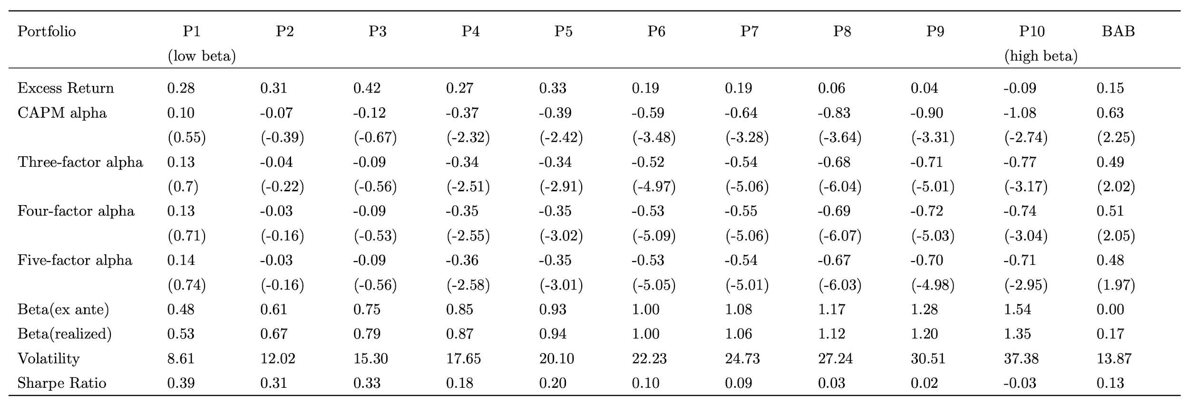

Table 1.

Table 1 reports our results for US stocks during 2008 - 2020. Our report uses the same measurements as the paper, including monthly alphas, annualized beta, and Sharpe ratios. The excess returns of P1-P10 are similar, and even negative for P10, which is a demonstration of the flat, or even negative sloped SML. The alphas from CAPM, three-factor, four-factor, and five-factor models display the same monotonic declining trend along with beta, with low-beta portfolio highest and high-beta portfolio lowest. Moreover, Sharpe ratios for P1-P10 also decline as the beta for the portfolio increases. Both alphas and Sharpe ratios are significant at 95% level. The result is in accordance with findings in previous work which worked on data years before, and it presents proof of existence and consistency of such alpha-beta phenomenon in recent years.

The BAB portfolio on the rightmost column delivers significantly high excess return and alphas estimated based on all models. Especially, the betting against beta strategy yields a monthly alpha of 1.3% with t-stats of 6.6. The portfolio has an ex-ante beta of zero and therefore is beta neutral as initially constructed. The table shows the same pattern with the paper’s result, despite different figures. A different time span and period definitely play a role here.

### **Visualization and Analysis**

Fig. x is a visualization of the table, including return, alphas, volatility, and Sharpe ratio for the beta-ranking portfolio. It is easy to notice that the BAB factor has a significantly high excess return.

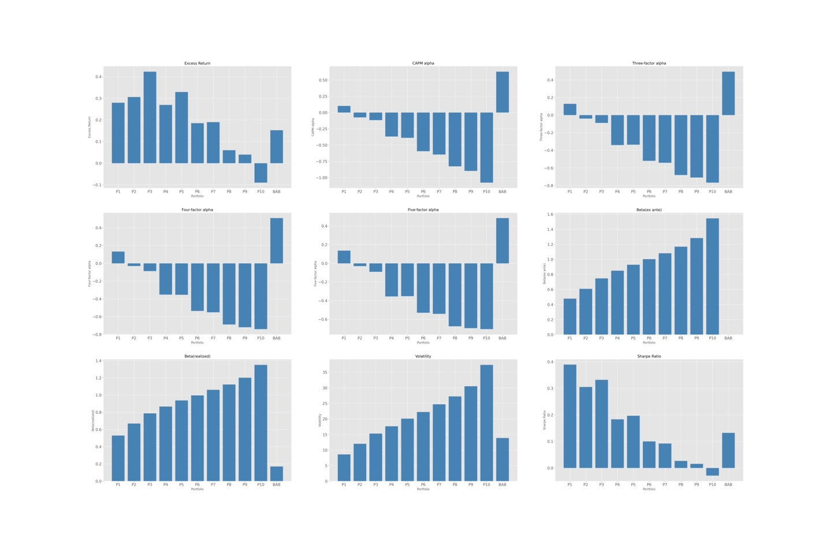

Fig.x shows the rolling beta of P1 - P10 respectively. We also report their loading on the factors, market (MKT), small-minus-large(SML), high-minus-low(HML), profitability factor(RMW) and investment pattern factor(CMA). Especially, looking at the loadings of the BAB portfolio gives us some hints on what stocks are more likely to be chosen by the BAB factor. Firstly, exposure to the RMW factor has always been positive during normal times, when the BAB factor performs well. We can therefore infer that the BAB factor helps filter out the most profitable stocks. However, this does not work during a financial crisis when all stocks are dragged by the market and the difference between profitable and non-profitable stocks is relatively small. Another noticeable factor is the CMA, on which the BAB factor also has large, positive loadings. The factor measures the difference between conservative investment minus aggressive investment. Not surprisingly, the BAB factor longs the low-beta stocks and shorts the high-beta ones is a risk-averse investment pattern. We also look at the cumulative return of each factor (Appendix) and the result supports the efficiency of the BAB factor. In short, the BAB factor looks for highly profitable stocks and is a conservative investment strategy.

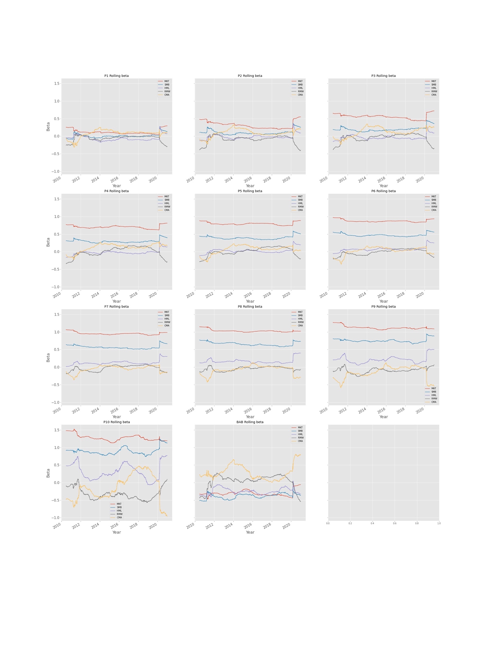

Then Fig. x shows the annual return of P1 - P10, from which we can easily find two significant drawdown periods for the BAB factor return: 2008 & 2020. Meanwhile, betas are highly volatile during the same period with sudden moves. It is obvious that the BAB portfolio has a bad performance during market crashes, which reveals an undesired property of the strategy: it loses money during a financial crisis when money is most needed. However, it is quite reasonable if we think about the strategy construction in detail. During a crisis, all the securities are impacted greatly by the market and market risk makes up a large proportion of the risk for almost every stock. Therefore, betas are moving towards one. When constructing the BAB portfolio, we leverage to long the low-beta stocks and deleverage to short the high-beta stocks to get a beta-neutral portfolio. However, during crises when all betas are close to one, the portfolio is longing far more than shorting due to the leverage and the portfolio actually has a positive beta. As a result, it is not surprising that the portfolio return drops as the market breaks.

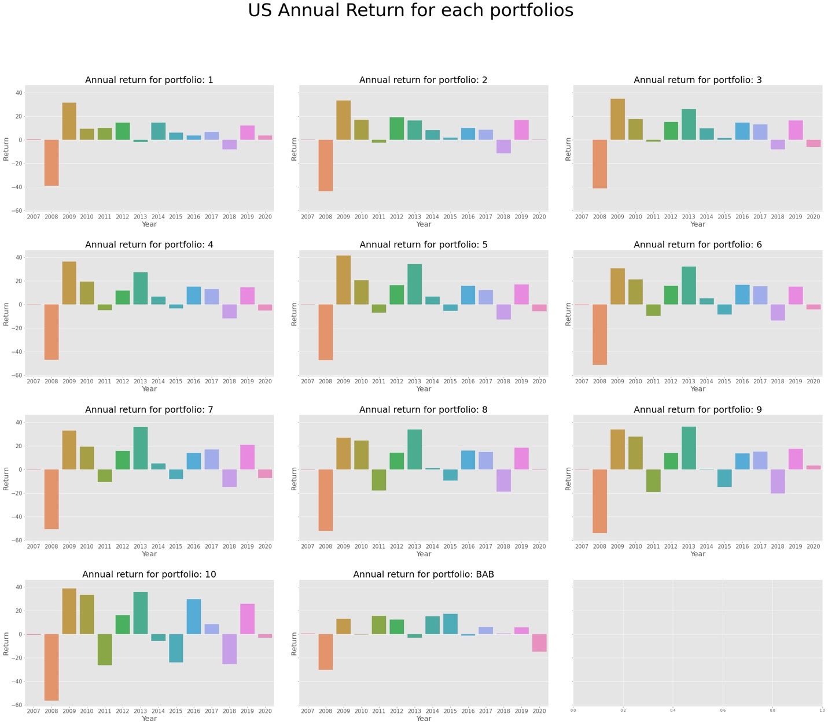

Based on this, instead of testing on the whole period, we test separately over the expansion period (2009 - 2019) when the US stock has a ten-year continuous bull market and post-GFC period (2009 - 2020).

### 

### **Over the Expansion Period (2009 - 2019)**

Results during the expansion period are shown in Table x. Compared with results for the whole period, the BAB portfolio delivers much higher excess return, significant alphas, and Sharpe ratio. Specifically, the excess return is 0.6 v.s. 0.15; the alpha estimated from CAPM is 1.30 v.s. 0.63; and the Sharpe ratio has a significant difference of 0.65 v.s. 0.13. The results show that the BAB strategy achieves a significantly good performance during normal time and bull market, but a financial crisis can easily destroy the excess return.

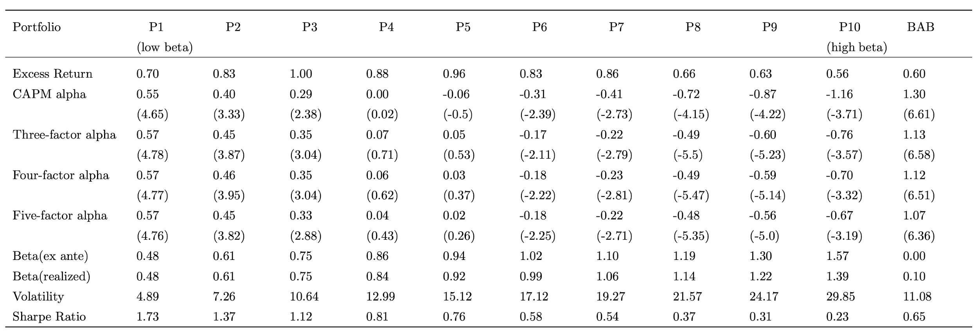

### **Post-GFC (2009 - 2020)**

The results of post-GFC period are shown in Table x. When excluding 2008, the BAB portfolio has a higher excess return, alphas, and Sharpe ratio, but not as high as when excluding both 2008 and 2020. It reaffirms the statement that the financial crisis eliminates the excess return generated by the BAB factor.

However, despite the decrease in profitability during the crisis, the strategy still yields a positive alpha and Sharpe ratio. In the original paper, the authors test on data during 1926 - 2012, which is a relatively long time, covering several economic cycles. And the effect on performance by occasion crash in the market was smoothened by a longer time of growing or bull markets. The post-GFC period that we test is between two dramatic financial crises and we may assume the period to be a full cycle, which rebounded after a financial crisis and headed to a new market crash. Therefore, the strategy in general is profitable, though the timing to stop loss during an upcoming crisis is important to secure a high excess return.

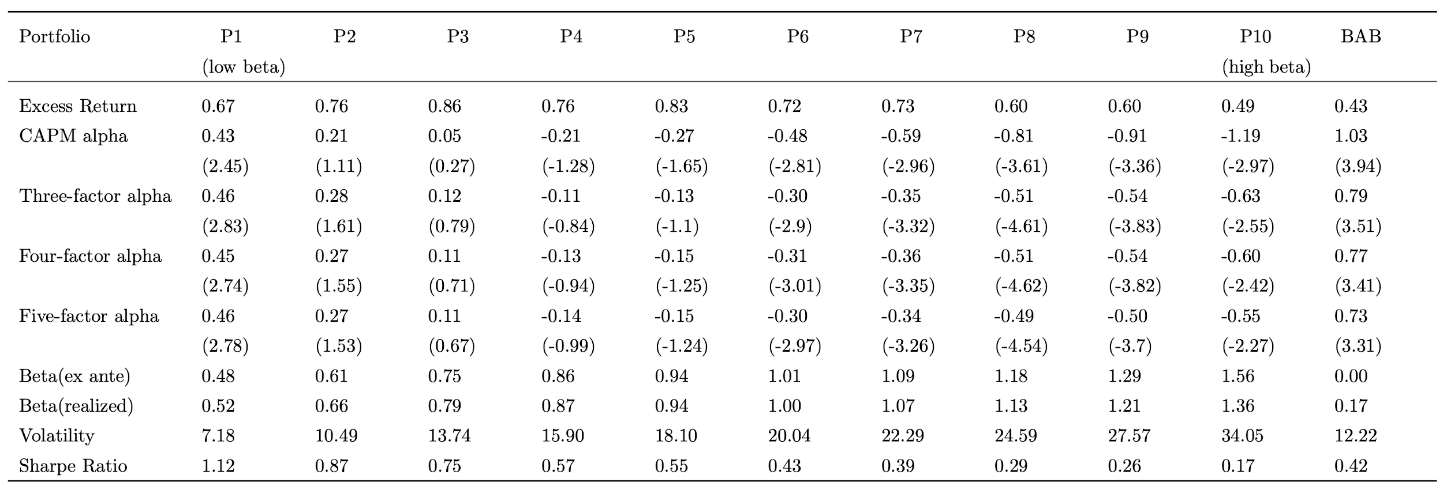

### **BAB factor validation**

We also compare our BAB factor with the BAB factor on the AQR website, which we assume to apply the same method with the paper, and thus with us. Fig. x displays the comparison of time-series daily factor returns. It is obvious that the patterns are quite similar and we generally manage to replicate the BAB factor. The scatter plot in Fig. 2 shows more clearly the accuracy of our beta. As mentioned before, we use the risk-free rate from AQR (Fig. x) to construct betas and the portfolio. Therefore, others being the same, we would attribute the slight difference and outliers to divergence in the stock universe. While we follow the instruction from the paper to include all stocks in the US market and remove the bad tickers, we do not know what stocks are excluded from the AQR universe. For example, we might have different definitions for ‘bad tickers’.

In general, we produce a correct BAB factor and thus, the results are reliable to deliver significant results and conclusions.

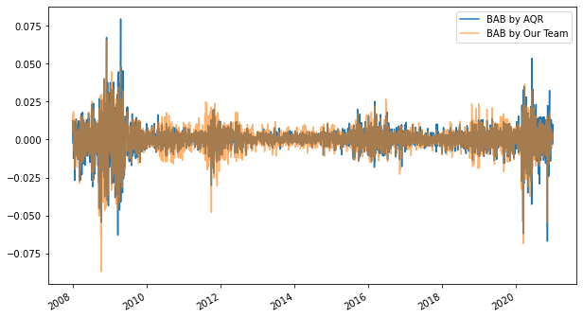

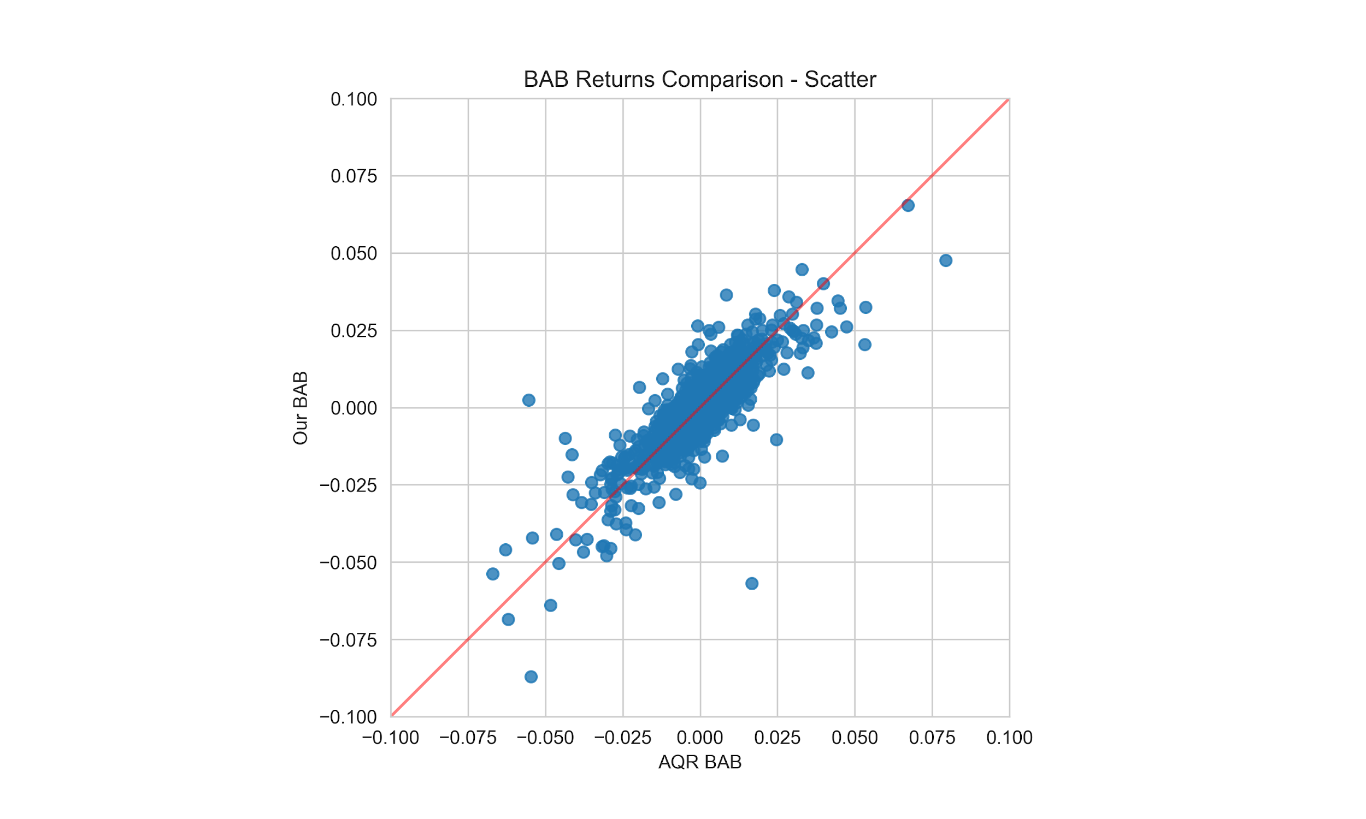

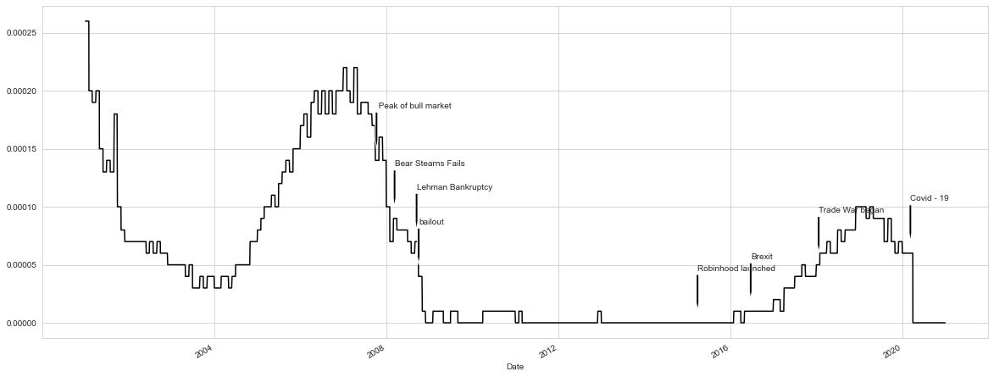

## **Extension to China’s A-share Market**

In this section, we extend our analysis internationally with the consideration of China’s A-share market from 2008 to 2020, because we are interested to learn if the BAB strategy is still effective outside the US equity market, especially in a younger and less developed market. In fact, we not only validate the effectiveness of the BAB strategy in China’s A-share market, but also see a better performance of the BAB portfolio comparably.

### **Over the Whole Period (2008 - 2020)**

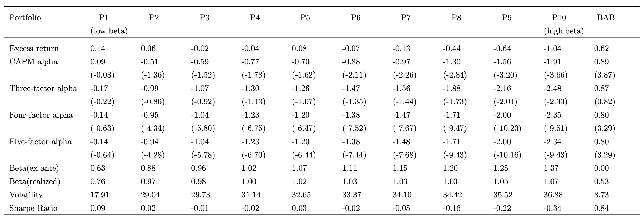

Table x above shows our results for China’s A-share from 2008 to 2020. Based on the estimated beta of each individual stock at each month, the stocks are categorized into one of the ten decile portfolios. The average excess returns of the ten portfolios are highly similar except for the last three deciles, in which the returns are highly negative. In the paper, the authors propose a statement that the relative flatness (possibly negative slope) of the security market line (SML) does not exist only in the US stock market, but is a global phenomenon, and our finding on China’s A-share market successfully validates this proposition. Moreover, the alphas from CAPM, three-factor, four-factor, and five-factor models have similar trends from low-beta to high-beta portfolios. In all four models, the alphas are monotonically declining across the ten decile portfolios with increasing value of the estimated beta. Also, most of the alphas in the four models are negative. Sharpe ratios also share a similar monotonic trend as the alphas, with only two positive values for the first two portfolios including the stocks with the lowest estimated beta, and negative values for all other eight portfolios.

On the rightmost column of table x, we also include the BAB portfolio performance for comparison. The portfolio is constructed as beta-neutral, which is demonstrated as an ex-ante beta of zero. Interestingly, we see consistent results in China’s A-share market as in the paper and in our own analysis of using the US Equity market data. In the paper and in our previous analysis, we find that the BAB factor provides outstanding portfolio performance with higher excess return and higher alpha. The same observations are made for China’s A-share market. The average excess return of the BAB portfolio is greatly higher than all ten decile portfolios and has a monthly abnormal return of 0.80% along with a t-stats of 3.29 with the return adjustment for the four-factor and five-factor models. It also generates a significant Sharpe ratio of 0.84.

Figure x shows the cumulative excess return of risk premium of the BAB portfolio from 2008 to 2020. Over the 12-year horizon, the BAB strategy generates a cumulative excess (abnormal) return of approximately 150% with the subtraction of risk-free rate. We can also see from the subfigure below that in about two-third of the years, the strategy is able to generate positive returns. [13]

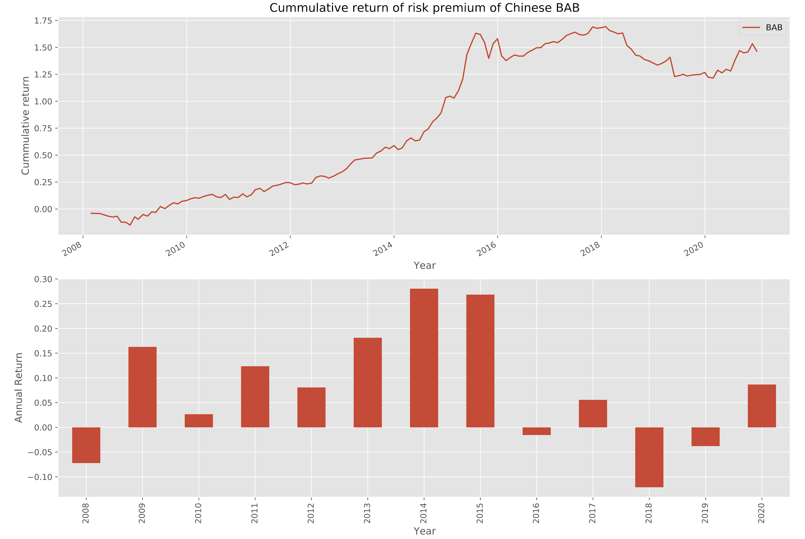

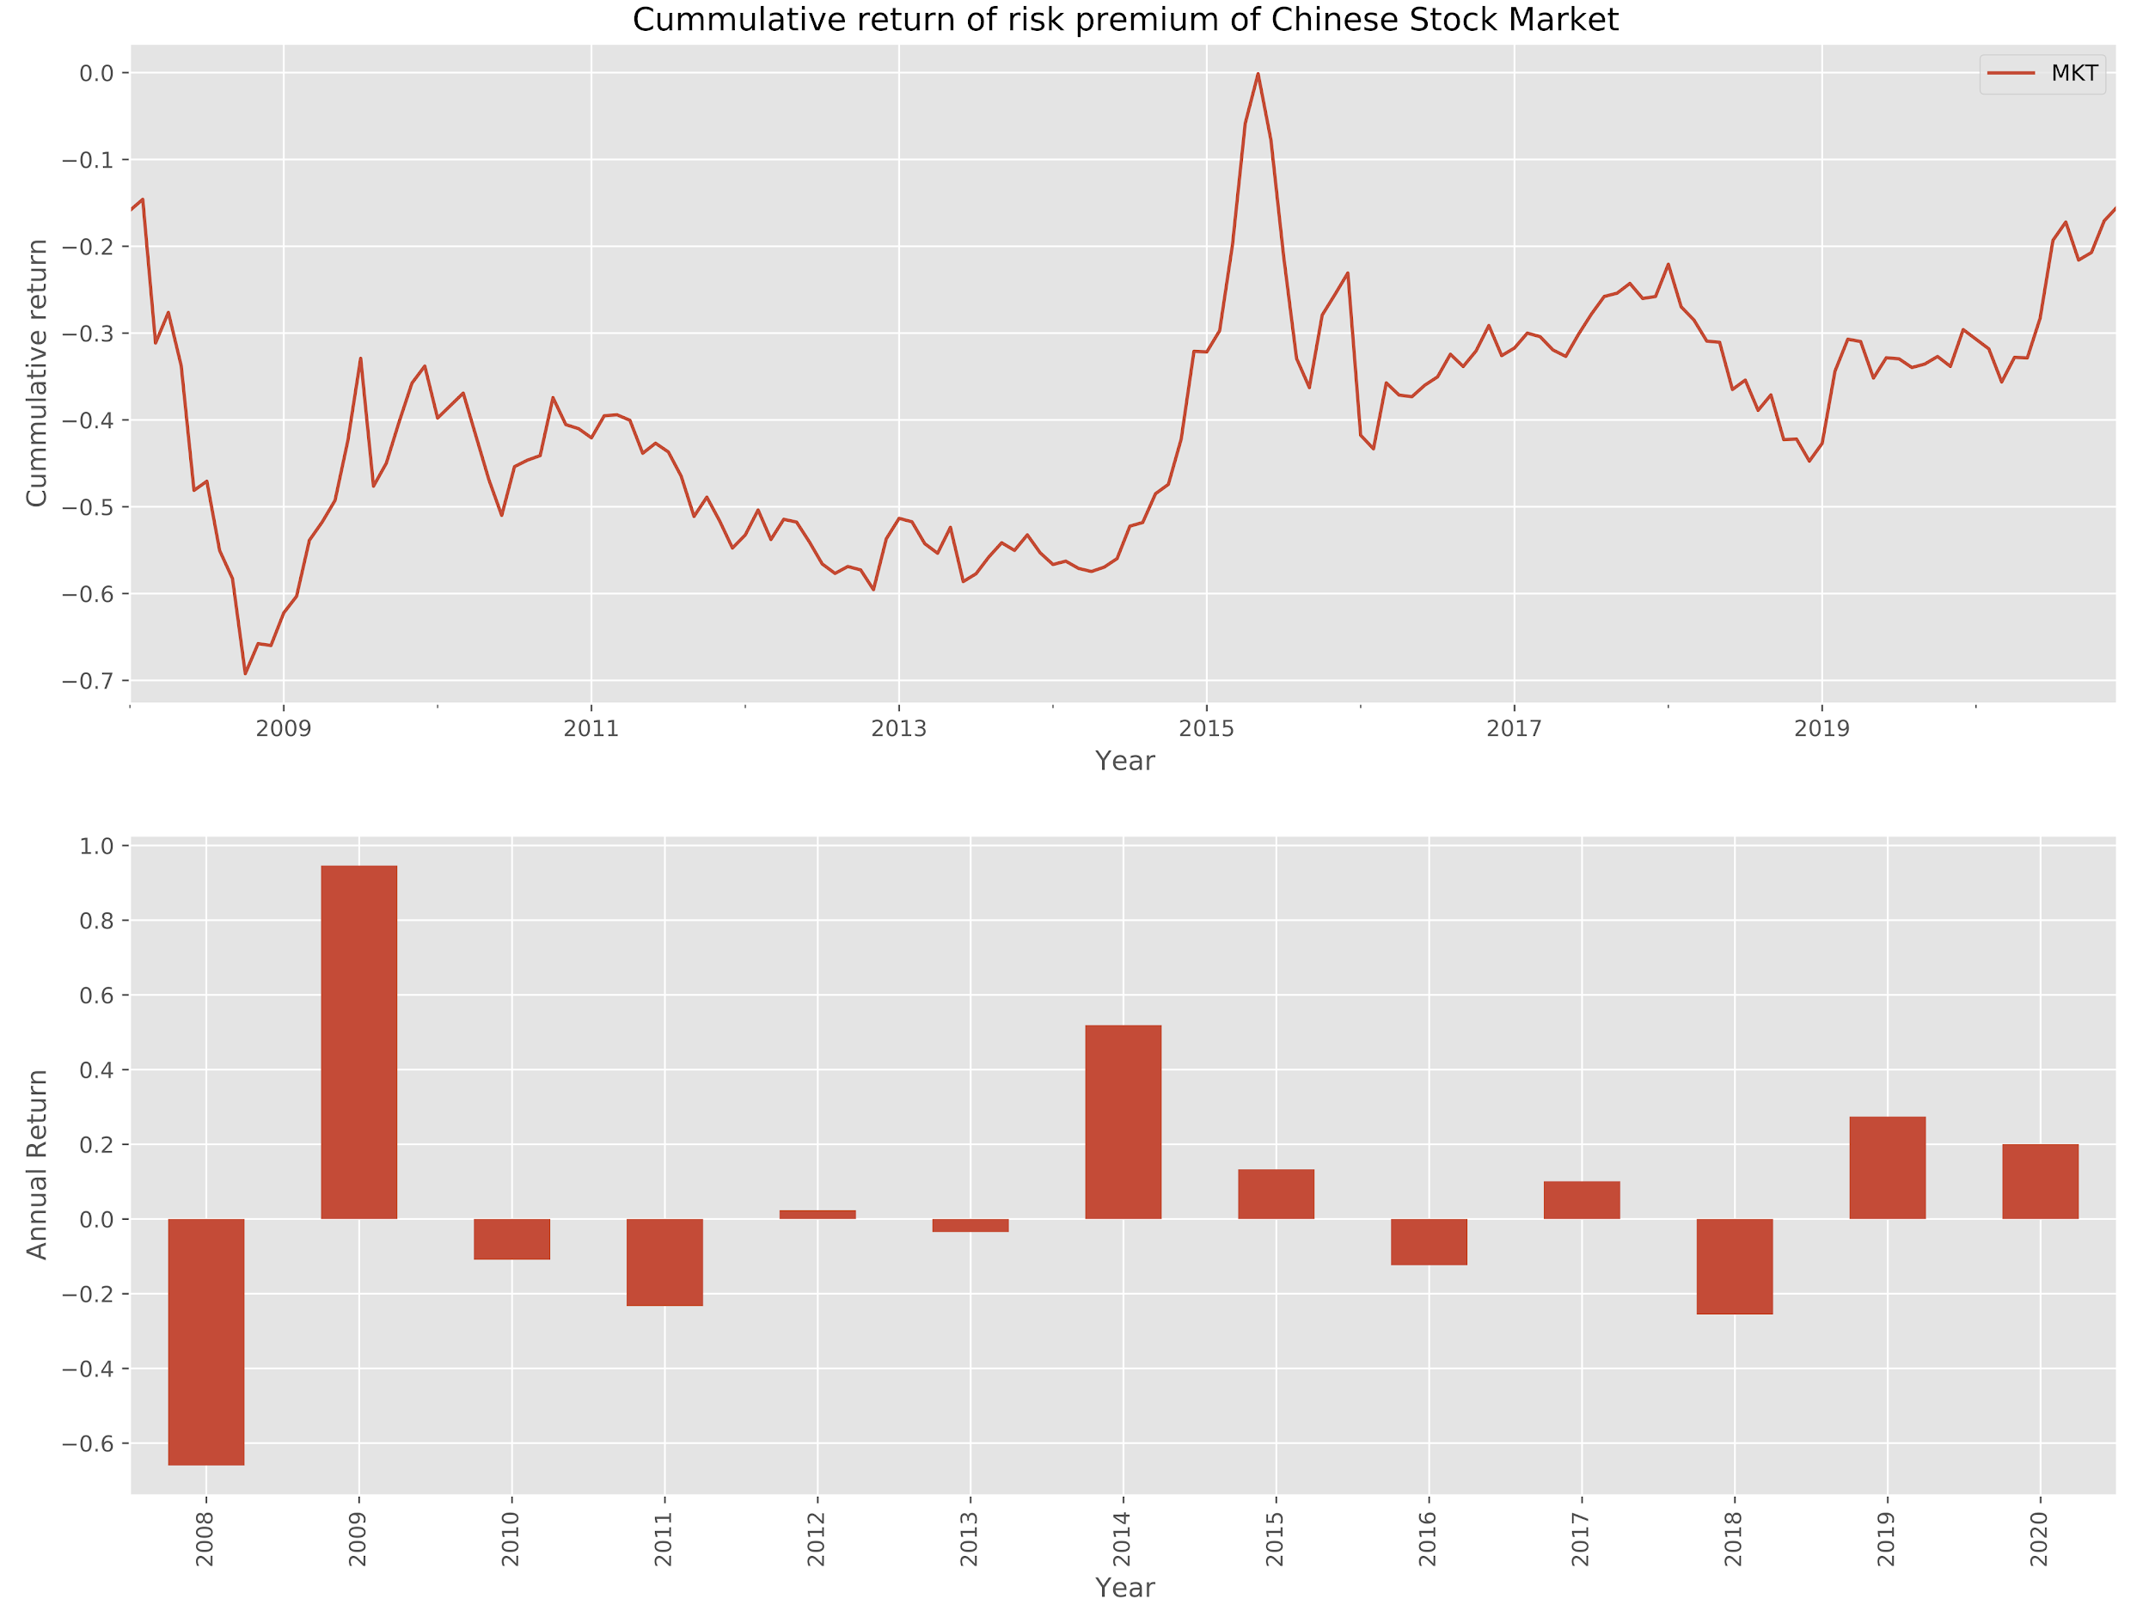

From figure x, however, the time series of cumulative return of the market portfolio is negative throughout the entire horizon, which indicates that the excess return is even lower than the risk-free rate. The first year of our analysis is 2008, in which the market portfolio experiences a dramatic drawdown of more than 65%. Among the 12 years of testing, in only one-third of the years the BAB strategy generate positive excess return.

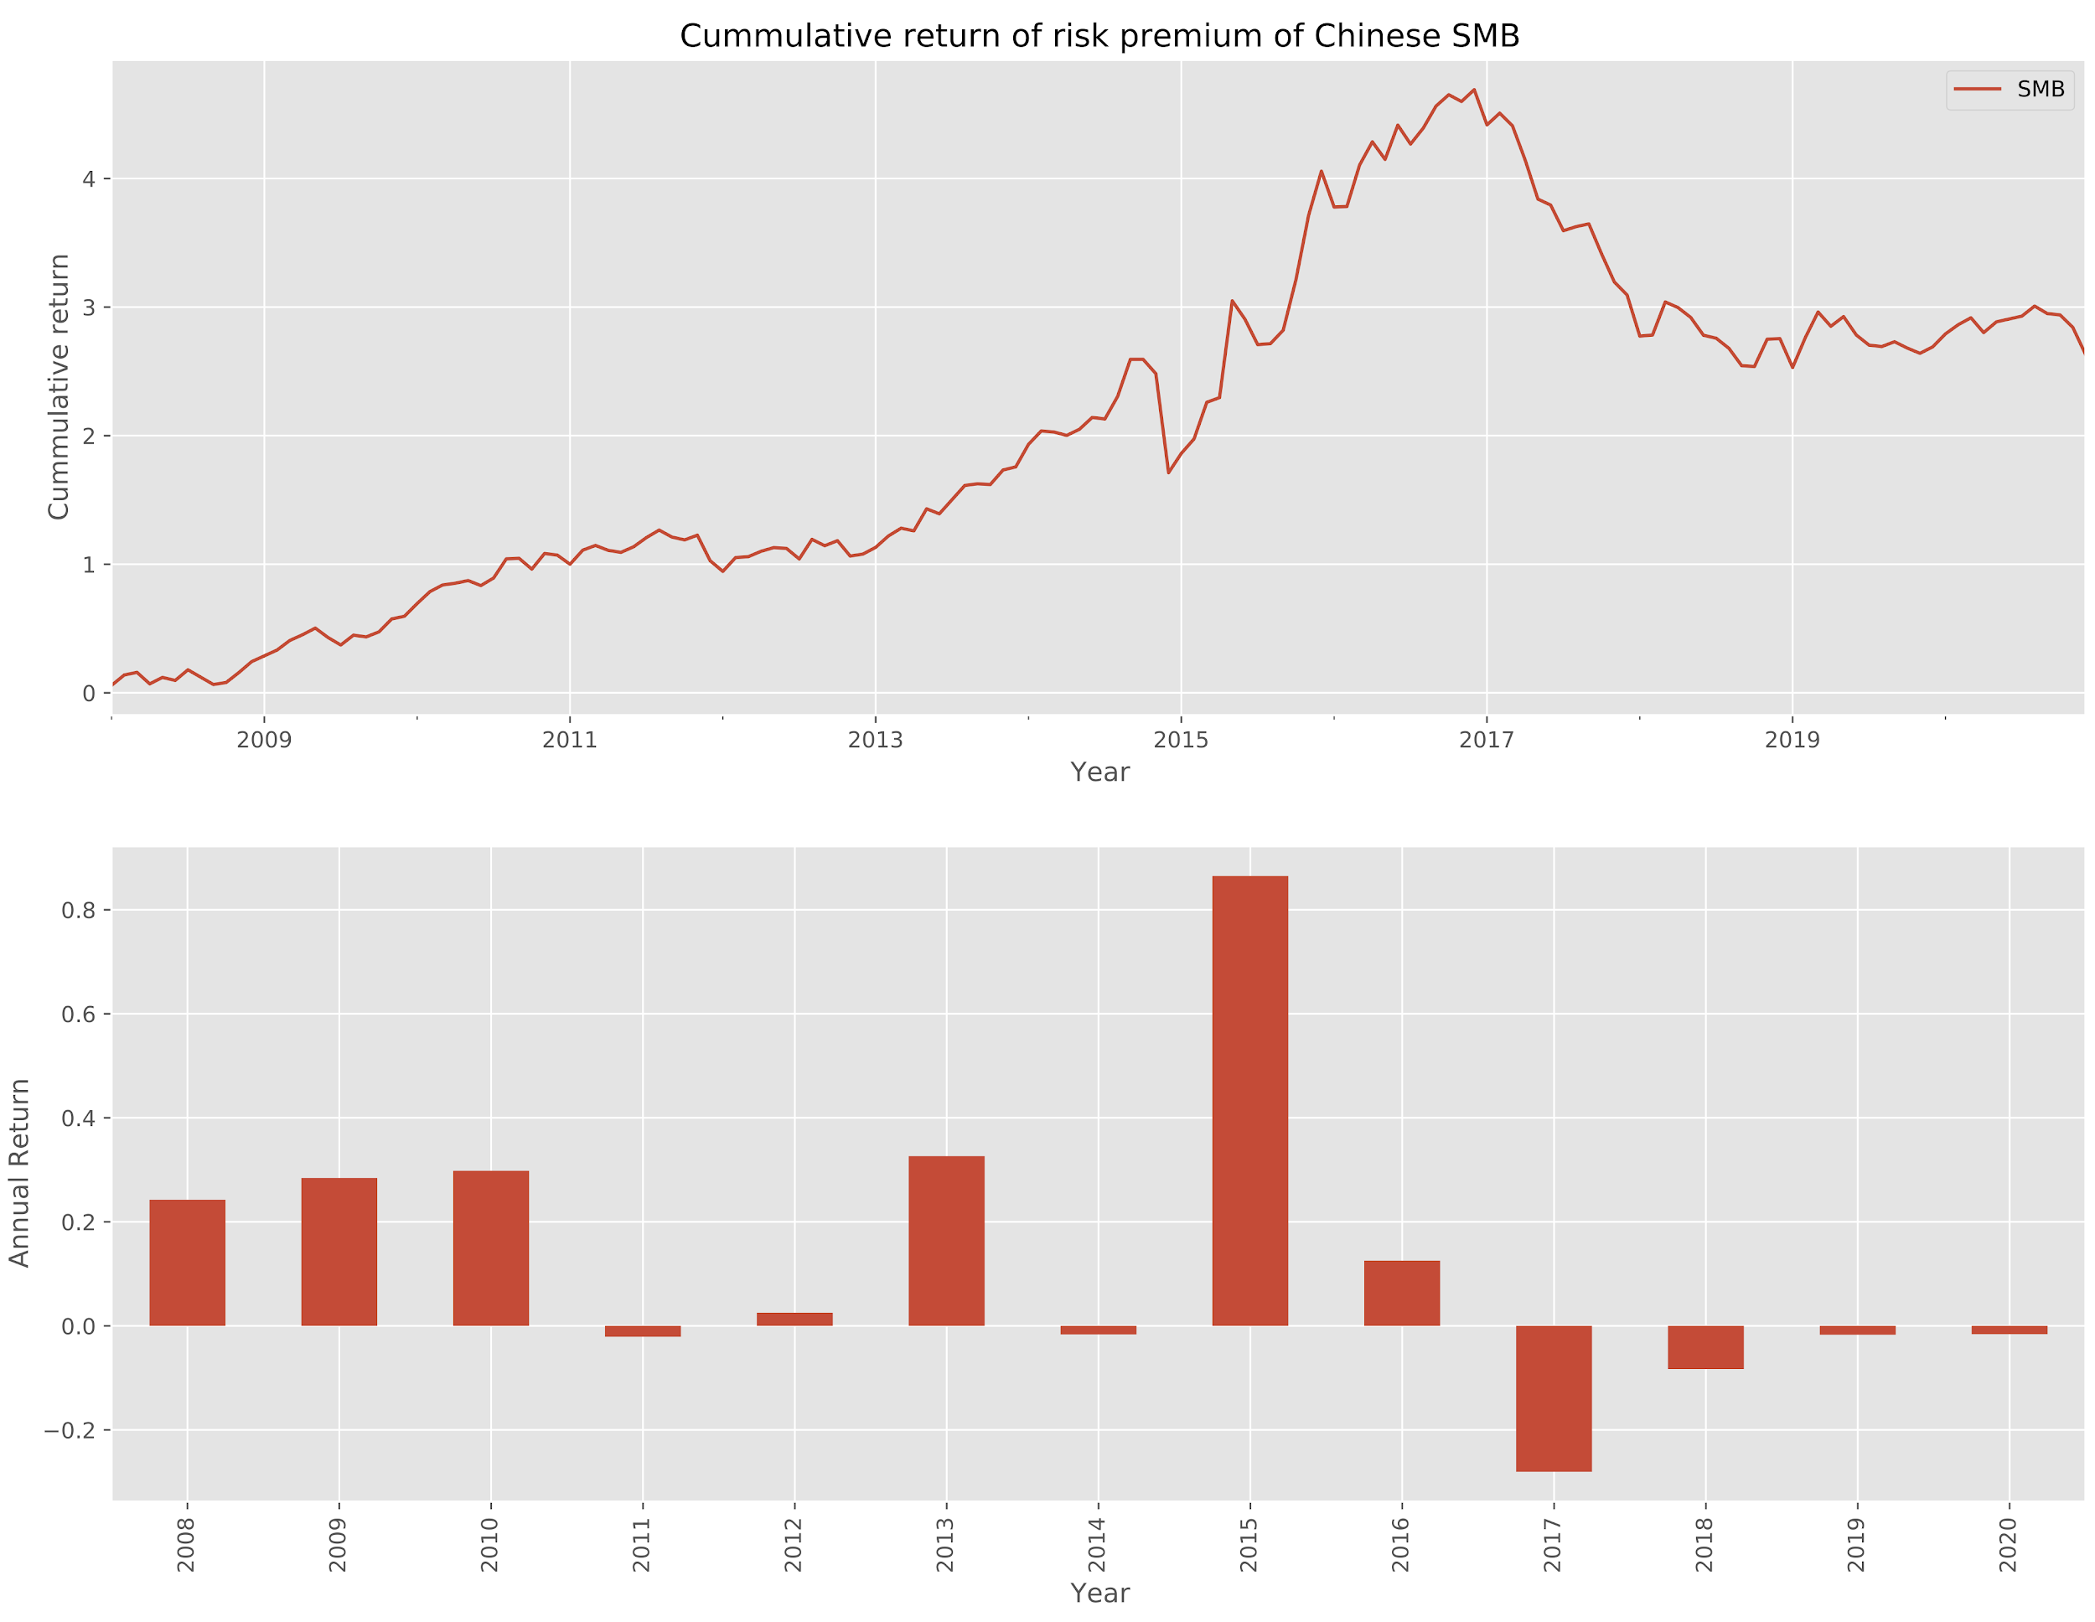

Another interesting finding is that the SMB (small-minus-big) portfolio generates excess returns throughout the years, especially before 2017 (approximate 400%). The construction of the SMB portfolio is by taking the difference of the monthly return of small-cap and large-cap portfolios. The Chinese stock market has the existence of “the effect of small-cap stocks”, especially in the years prior to 2017. Because Chinese stock market has a late start (The Shanghai Stock Exchange and the Shenzhen Stock Exchange opened in the end of 1990), it is still an emerging and unstable market that attracts many irrational individual investors who buy stocks not for investment but for speculation purposes. Therefore, small-cap stocks are normally their targets with higher returns and greater risks. With a lot of funds flowing into the small-cap stocks, their prices are pushed even higher. Since 2017, however, the small-cap stocks gradually lose their superiority, which is not only a result of the increasing sophistication of the equity market, but also an inevitable trend of institutionalization.

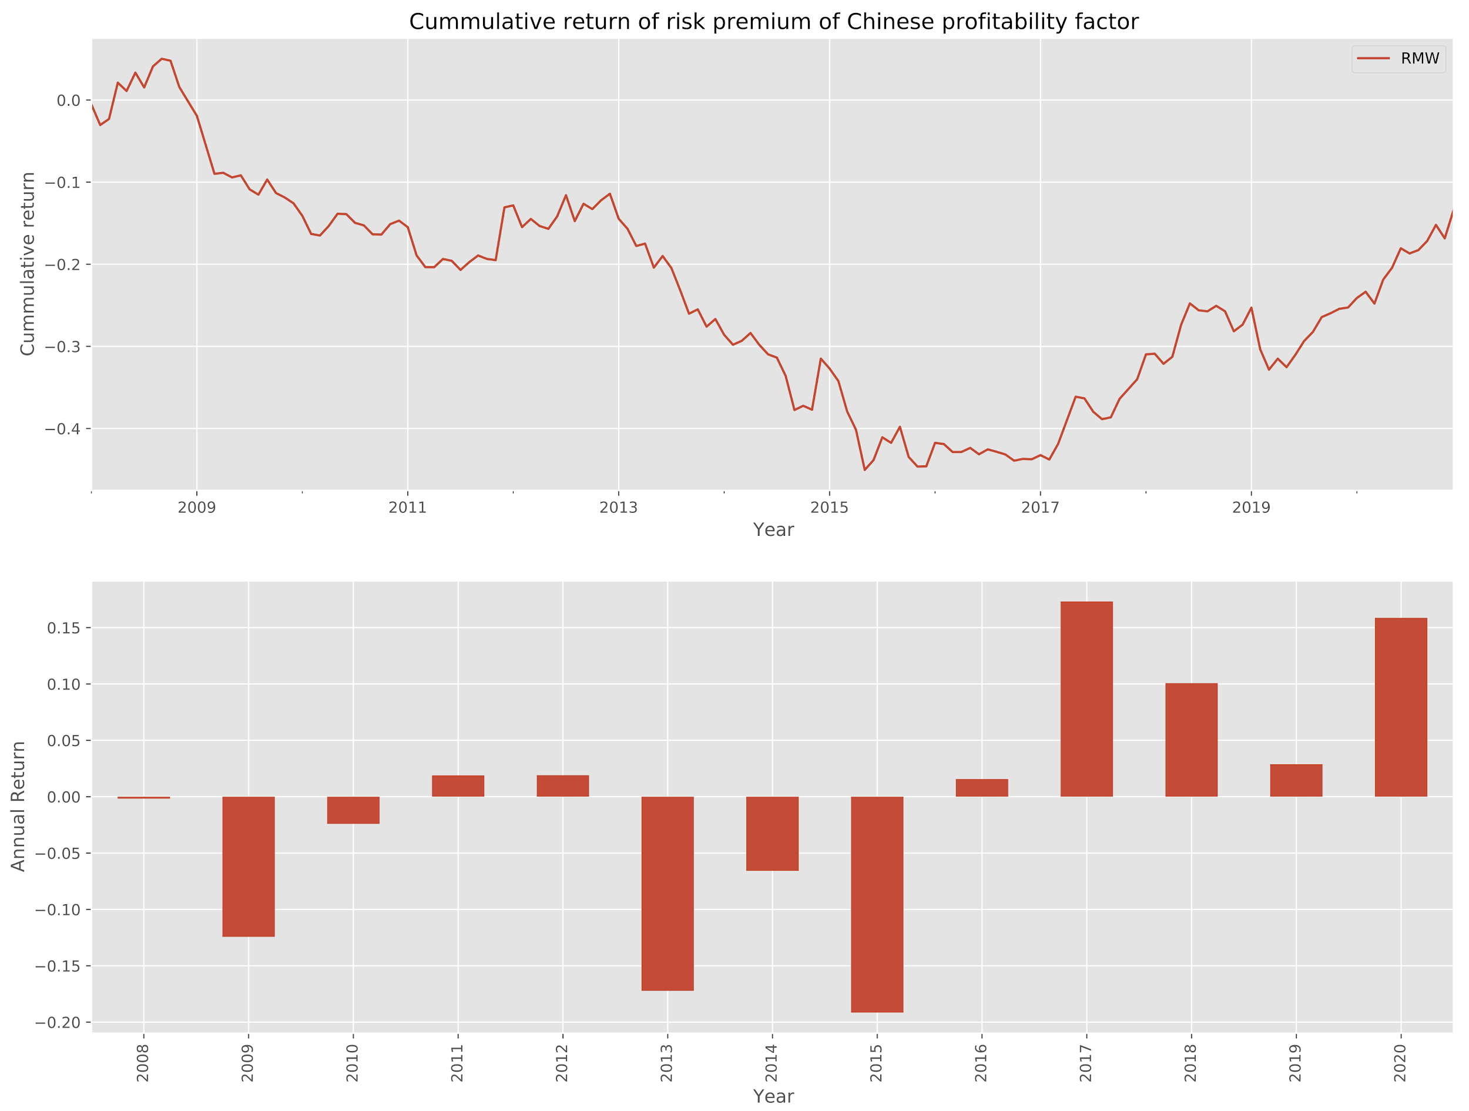

On the contrary, the RMW (high-profitability-minus-low-profitability) portfolio generates a negative cumulative return throughout the time horizon (figure x), and this phenomenon has the same reasoning as the phenomenon of SMB portfolio. Because the Chinese stock market is still young with high fluctuations, irrational investors are likely to invest in small-cap stocks for speculation, and these stocks have a high possibility with low or even negative profits.

One of the main reasons why the year 2017 appeared to be a watershed is that the Shenzhen-Hong Kong Stock Connect program kicked off at the end of 2016. Such a program together with its predecessor the Shanghai-Hong Kong Stock Connect program that started at the end of 2014 allows more overseas investors to invest in China's A-share market. The tradable securities included in this program are stocks that are traded on Shenzhen Stock Exchange and have a market capitalization higher than 6 billion Chinese Yuan. The Shenzhen-Hong Kong Stock Connect program was particularly important because the stock universe on the Shenzhen Stock Exchange is larger than the Shanghai Stock Exchange. With the Shenzhen market being opened, it marked the milestone where overseas investors have access to both exchanges in China’s A-share market.

More importantly, the total amount of capital flowing into China’s market via the two Stock Connect programs have dramatically increased in the past few years as we can see in figure x. The funds from these channels are called “smart money” which means the market sees overseas investors as informed traders. In addition, the inflow/outflow of these funds on their target securities are open to the public on a daily basis. Inevitably, such funds have a huge influence on China’s stock market as they have followers who act accordingly. In addition, from what has been observed in the past few years, the overseas funds that flow into China’s market typically favor so-called “core assets” which mainly include firms that have strong profitability, dominance in their industries, and irreplaceable product/service in the market. Therefore, the preference of the overseas funds has an effect on tilting towards the RMW and the opposite side of SMB in the overall market which were shown in the earlier part.

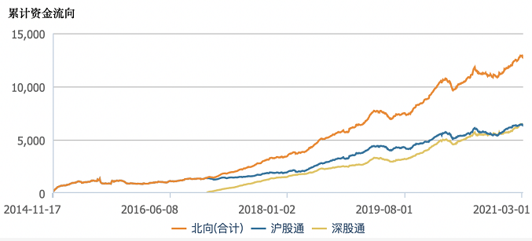

SZ-HK

SH-HK

Total

Figure x: Source Wind Data. The blue line represents the total amount of capital into China’s A-share market via Shanghai-Hong Kong Stock Connect. The yellow line represents the total amount of capital into China’s A-share market via Shenzhen-Hong Kong Stock Connect. The orange line represents the total amount of capital into China’s A-share market via both Connect programs. The unit of y axis is 100 million Chinese Yuan.

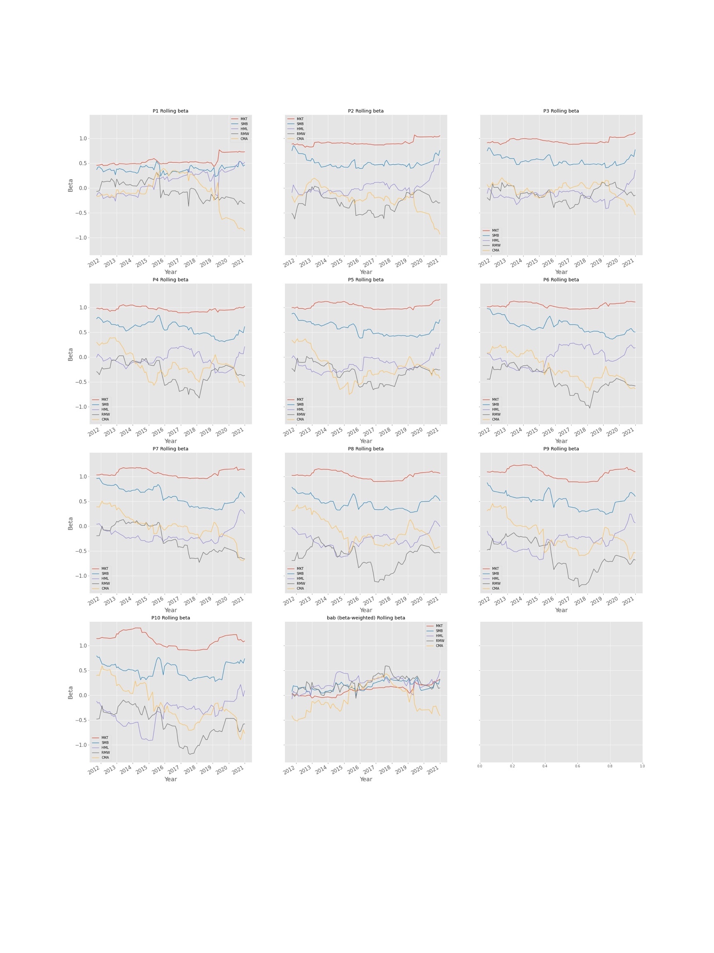

Figure x shows the Fama-French 5 factors’ loadings on quantile portfolios’ excess return and BAB by running a rolling regression with a window of 30 months. Comparing the two extreme portfolios P1 and P10, we can see that the factors’ loadings on P1 have significantly smaller values than those on P10. Additionally, some clear patterns in loadings are discerned: firstly, P1 has smaller loading on market factors, which is as expected; secondly, the differences in loading on SMB and HML show that P1 is mainly consisted of stocks with large market capitalization and high book-to-market ratios , while P2 is formed by stocks with low market capitalization and small book-to market ratios. Thirdly, the P10 has significant weight on stocks that generate unstable profit and make minimal investment, which indicates that investors that would long P10 are dominated by speculators.

Looking at the loadings of BAB on factors, we observe that CMA has a more dramatic change across time, whereas the loadings on other factors mostly fluctuate between 0 and 0.5.

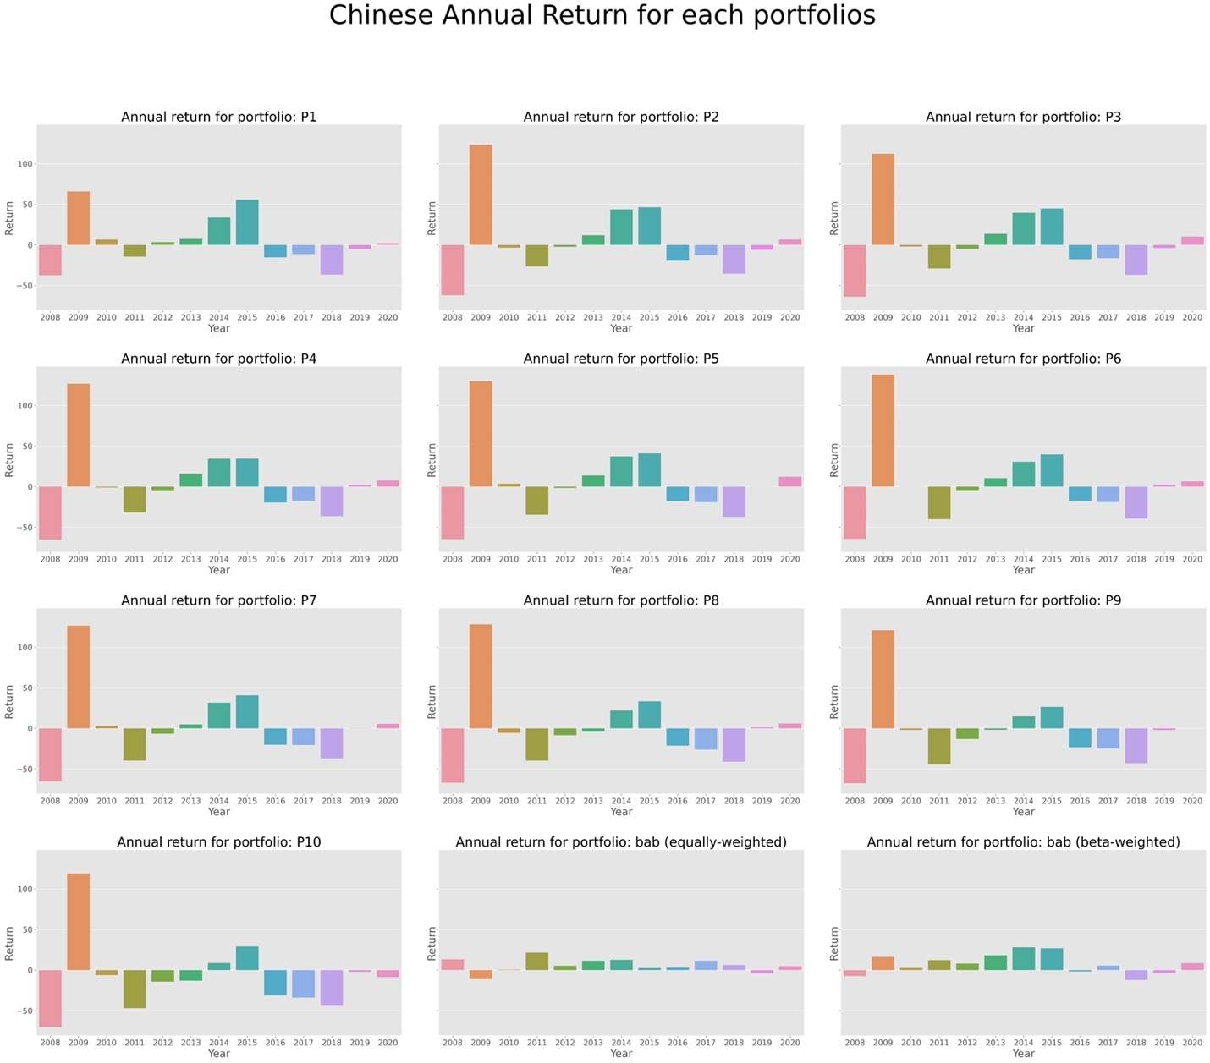

Figure x displays the annual return of the ten decile portfolios in China’s A-share market. We see that for each portfolio, there is a consistent drawdown in the year of 2008, which is a result of the GFC. Also, the individual stock’s beta converges to one during a crisis as the market movement has profound impact on all the securities traded, and market risk is significantly contained in each stock’s total risk. When all the batas are close to one, the BAB portfolio has much more longing than shorting to generate appropriate leverage. Another financial market turbulence is in the year of 2020, in which the covid-19 caused a significant impact on global financial markets. Therefore, instead of considering the whole testing period from 2008 to 2020, we also analyze the BAB portfolio performance over the expansion period (2009-2019) and post-GFC period (2009-2020).

### **Over the Expansion Period (2009 - 2019)**

Table x excludes the GFC period (the year 2008) as well as the stock market turbulence due to the pandemic (the year 2020). Compared with table x, which includes both the year 2008 and 2020, we see higher excess returns, alphas, and Sharpe ratios across the ten decile portfolios. And the BAB portfolio still generates decent returns, alphas, and Sharpe ratio. For instance, the BAB strategy generates abnormal monthly returns ranging from 0.78% to 0.92% using different adjustments and factors used. Unsurprisingly, the same monotonic trend still exists for alphas and the Sharpe ratios.

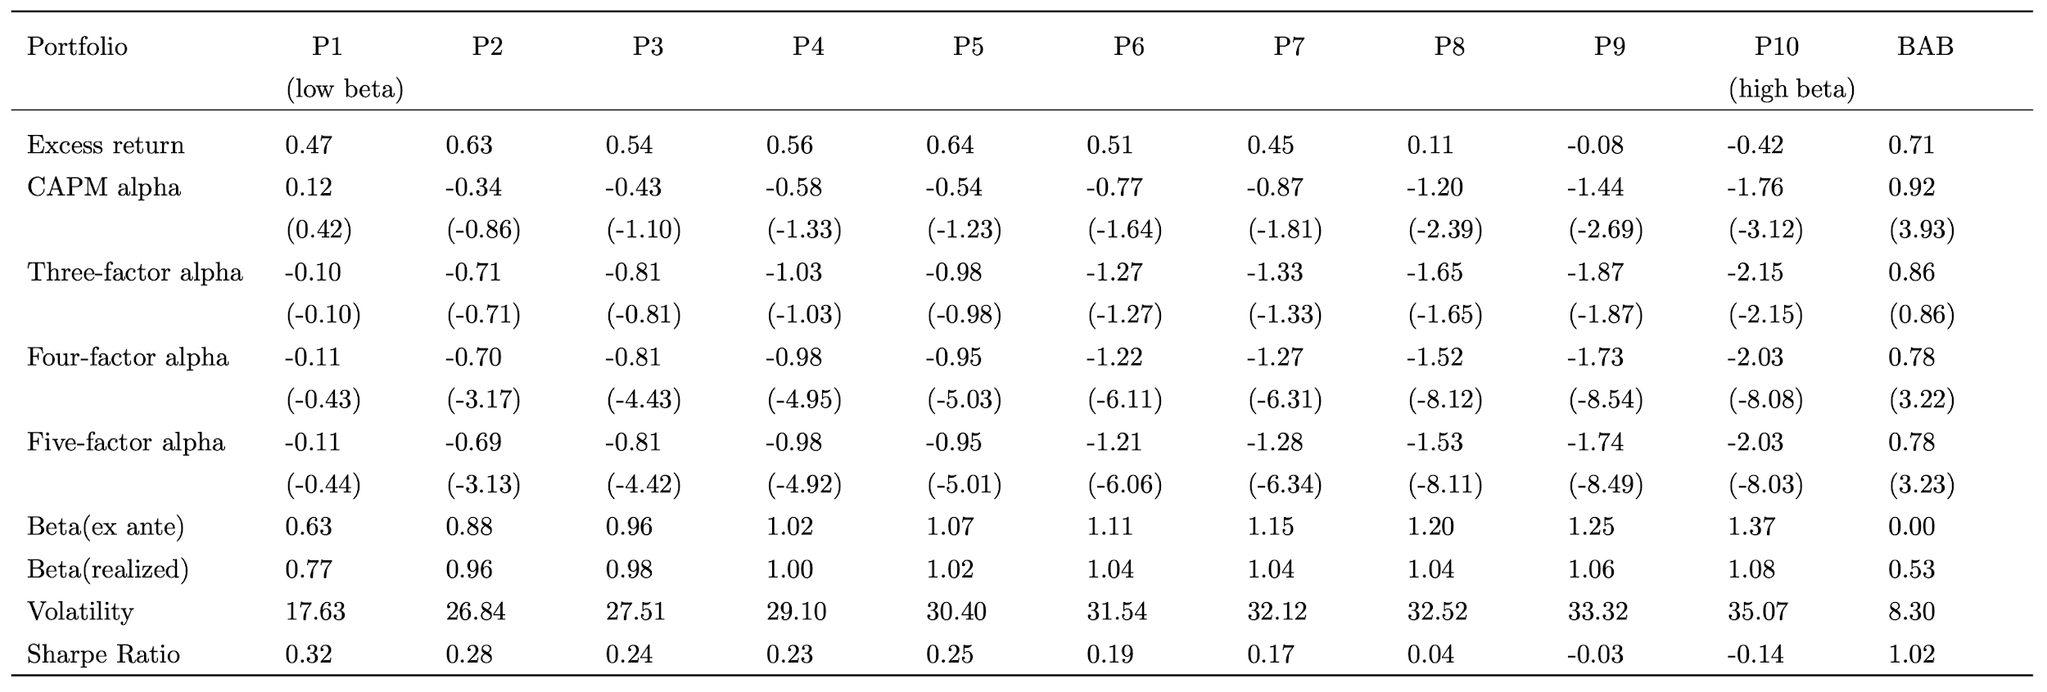

### **Post-GFC (2009 - 2020)**

With the exclusion of only the GFC, we see similar performances for both the decile portfolios as well as the BAB portfolio. This finding is reasonable as the GFC has a more profound and severe impact globally on the financial markets.

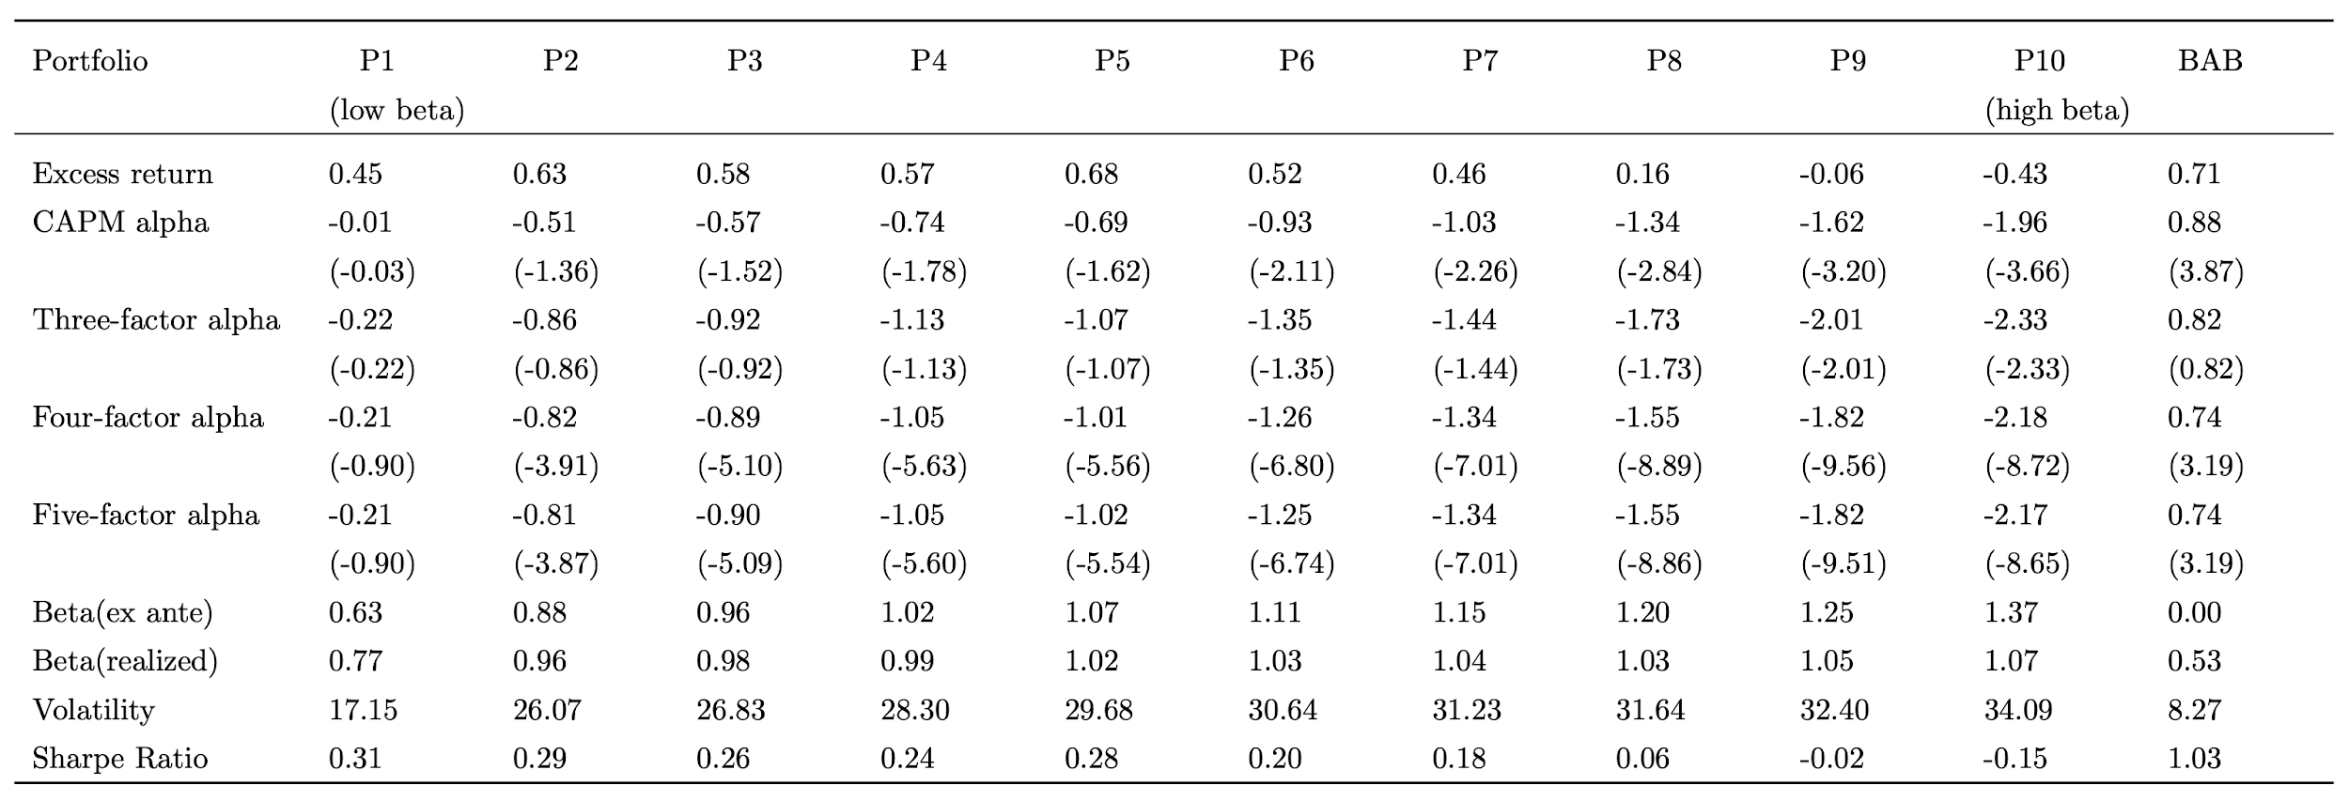

### **Comparison with the US Equity Market**

We now discuss BAB factor effectiveness by comparing its performance in the US equity markets (table xx) and in China’s A-share market (table xx) from 2008 to 2020.

Comparing the ten decile portfolios in both markets, we see that for the Chinese market, the BAB factor generates an average return of 0.62% and a Sharpe ratio of 0.84, whereas the average return is only 0.15% and SR is 0.13 for the US market. The superior effectiveness in the Chinese market is a result of the significant difference between the performance of low-beta portfolios and the performance of high-beta portfolios: the ten decile portfolios’ average excess returns have a range of 1.28% (-1.04% to 0.14%), which is approximately twice as high as for the US market (-0.09% to 0.42%). Such a wide range is mainly due to the significant negative return for P10 (including stocks with the highest estimated betas) for the Chinese market. One potential explanation for P10’s negativity is that Chinese investors are largely composed of individual investors who tend to be aggressive and are willing to invest in riskier stocks in exchange for potentially higher returns. Practically, however, the prominent abnormal returns of the BAB strategy can be reduced by constraints in the Chinese stock market such as shorting limits and inconvenience.

# **Strategy Back-testing Results**

In this section, we investigate the BAB trading strategies utilizing both the Chinese market’s BAB factor and the US market’s BAB factor. More specifically, we include four strategies: buy-and-hold (China), buy-and-hold (US), equal-weight-monthly and inverse-vol-monthly. We include the time series of strategy return in 12-year backtesting as well as important metrics used to determine portfolio performance such as Sharpe ratio, max drawdown, Calmar Ratio[14], skewness, and kurtness. We assume a risk-free rate of zero for simplicity.

## **Over the Whole Period (2008-2020)**

The buy-and-hold (China) strategy is a simple strategy that only holds China’s BAB monthly-rebalancing portfolio that is discussed in the last section, whereas the buy-and-hold (US) strategy only holds the US’s BAB portfolio. The equal-weight-monthly strategy sets an equal weight for China’s BAB portfolio (50%) and the US’s BAB portfolio (50%). The inverse-vol-monthly strategy assigns the inverse of volatility as the weights for the two BAB portfolios.

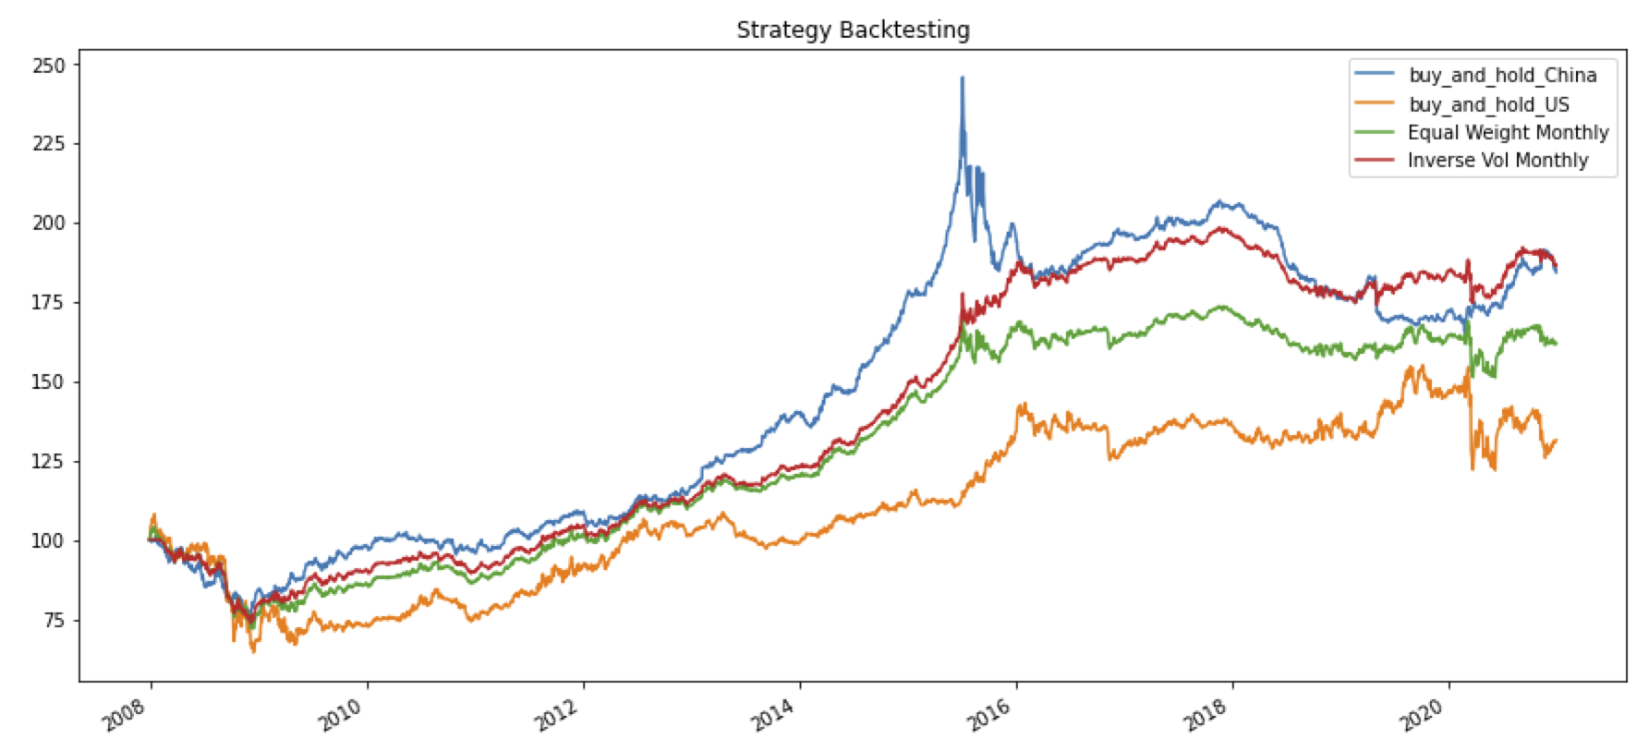

Figure x plots the cumulative return for the four strategies introduced above. There are two major drawdowns that are consistent in all strategies caused by the GFC and the Covid-19. The GFC has a similar effect on all strategies, whereas the US stock market is influenced the most by the Covid-19. On March 16th alone, the Dow Jones Index dropped by 13%, and circuit breakers triggered four times within ten days. Moreover, there exists a significant drawdown for the buy-and-hold (China) strategy alone, which is a result of Chinese stock market turbulence from 2015 to 2016. This return drop also reflects on the equal-weight-monthly strategy. Overall, the buy-and-hold (China) strategy and inverse-vol-monthly strategy generate the highest cumulative return, whereas the buy-and-hold (US) strategy has the worst performance throughout the 12-year time horizon.

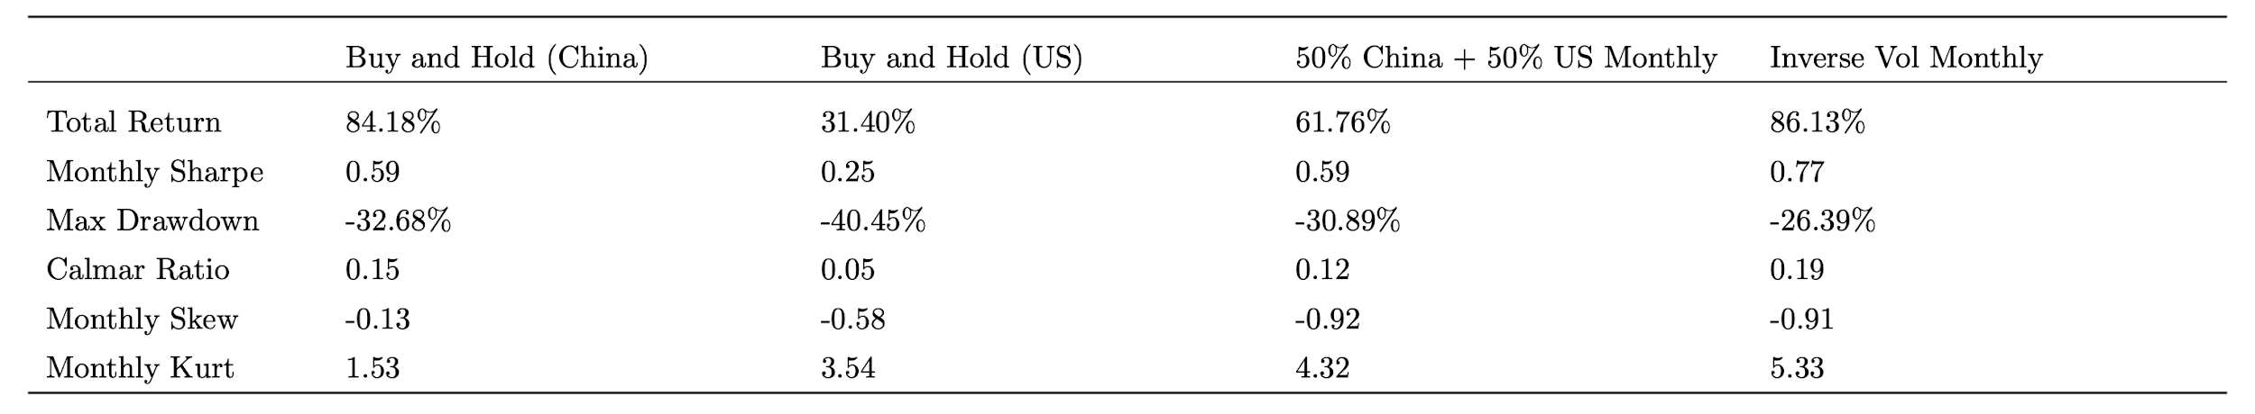

Table x summarizes the results. The inverse-vol-monthly strategy has the highest monthly Sharpe ratio as well as the lowest maximum drawdown, which indicates a promising risk-adjusted performance of the strategy. The same conclusion can be drawn with the consideration of Calmar Ratio, as this strategy has the highest Calmar ratio of 0.19. Both the buy-and-hold (China) and the equal-weight-monthly strategy have a monthly Sharpe ratio of 0.59 and a similar max drawdown, but the former has a less negative monthly skewness. The steady performance of the buy-and-hold (China) strategy is unsurprising as in the last section, we have shown with multiple evidence that the BAB strategy works better in China compared to its effectiveness in the US. Consistent with figure x, we see poor performance of the buy-and-hold (US) strategy comparably, with the lowest Sharpe ratio and worst max drawdown.

## **Post-GFC (2014-2020)**

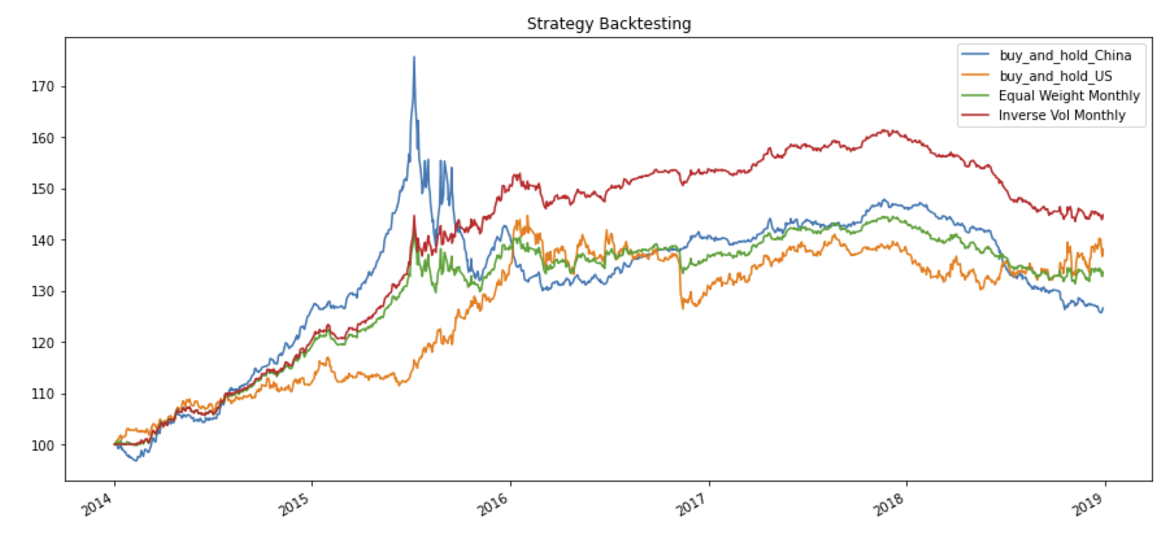

Table x and figure x show the four strategies’ performance from 2014 to 2020. We see

from the clear evidence that the inverse-vol-monthly strategy has superior performance with a

much higher monthly Sharpe ratio of 1.49, the highest Calmar ratio of 0.70 and an acceptable max drawdown of -11.07%. Moreover, without the influence of the GFC, the buy-and-hold (US)

strategy outperforms the buy-and-hold (China) as the Chinese market is greatly affected by the

Chinese financial turbulence in 2015 and 2016. Another potential reason is that the Chinese

market is less affected by the GFC compared to the US market.

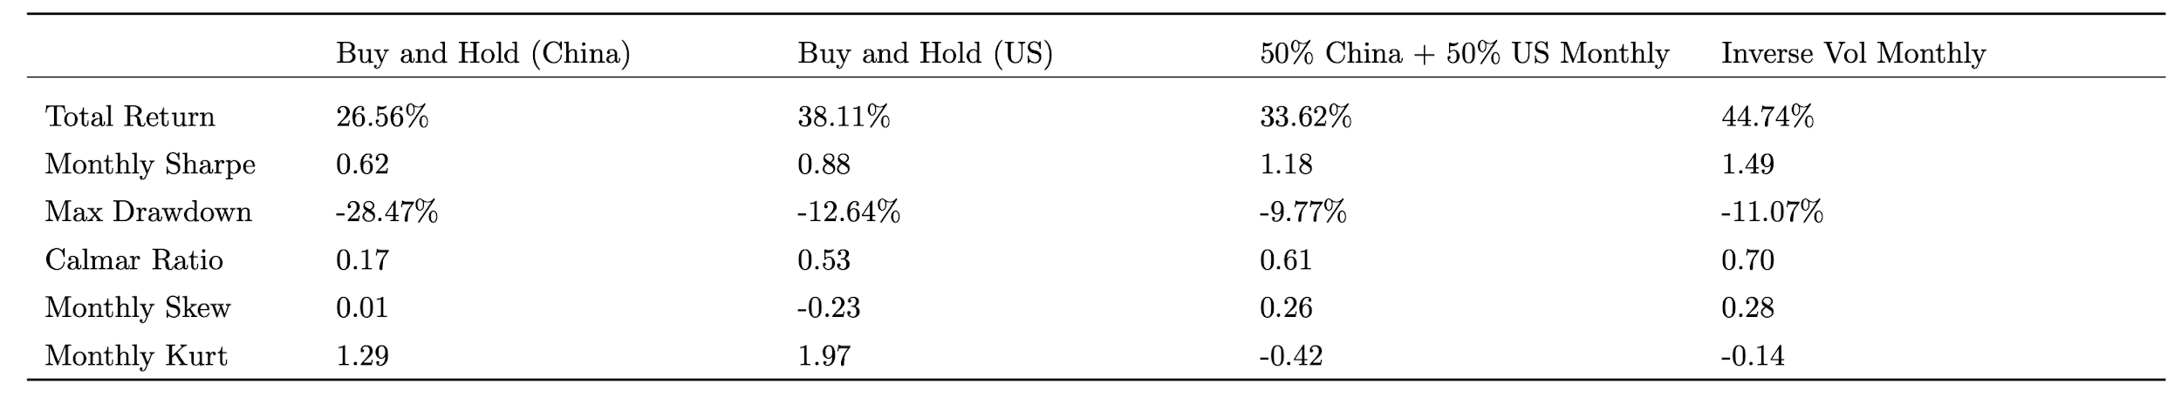

Overall, we see a promising and consistent outperformance of the inverse-vol-monthly strategy which not only combines the two BAB factors in both countries but also takes into consideration the dynamic volatility over time.

# **Conclusion**

The relationship between return and risk in the real world has a consistent deviation from CAPM, as has been proved by many previous studies. Specifically, researchers found that low-beta stocks yield a higher return while high-beta stocks yield a lower return, which forms a flatter SML. Constraints leverage and pursue for a higher return during a bull period by mutual funds and individual investors are reasons proposed to account for the phenomenon. And a strategy to take advantage of this deviation is naturally generated. In this paper, we replicate the BAB (betting against beta) factor proposed by Frazzini, A., Pedersen, L.H.,(2013) and validate the effectiveness of the BAB factor in recent years (2008 - 2020). The BAB portfolio delivers significant excess return and Sharpe ratio, especially during normal years and bull markets.

However, the portfolio has a bad performance during financial crises, such as the GFC(2018) and Covid-19(2020), which will eliminate the excess returns achieved by the strategy. And by analyzing the factor loading on common factors, such as market, SML, HML, RMW, and CMA, we find that the BAB factor tends to look for profitable stocks and behaves more like a conservative investment strategy.

We further test the strategy separately over the expansion period (2009 - 2019) and post-GFC period (2009 - 2020) and analyze results. There is clear evidence that the BAB portfolio is making money during the expansion period and losing money during the crisis. The phenomenon can be explained by the fact that all betas are closing to one and thus the BAB factor has a positive beta, leading to a drop in return as the market crashes.

Based on the fact that a flat SML line also exists in developing markets, we examine the effectiveness of the BAB factor in developing markets by taking China’s A-share market as a sample. We implement the BAB strategy and find similar results with the US equity market that the factor is still effective in recent years. Specifically, the BAB factor is more significant and robust, yielding higher excess returns and a Sharpe ratio of 0.86 in China’s market. We mainly attribute the reason to limitations on shorting by Chinese regulations.

Lastly, we construct four trading strategies based on the BAB factor: buy-and-hold (China), buy-and-hold (US), equal-weight-monthly and inverse-vol-monthly and implement backtest both in the period of 2008-2020 and 2014-2020. Results show that the inverse-vol-monthly strategy is the most profitable and promising strategy as it gives the highest Sharpe ratio, highest Calmar ratio, and lowest max drawdown in both testing periods, which shows its capability of generating a consistent and decent return and controlling downside risk simultaneously.

# **Future Work**

Firstly, as the original paper suggested, the phenomenon of an imbalanced relationship between return and beta also exists in other asset classes, e.g. bonds, credit, foreign exchange, and international markets. The test as well as the extension of the BAB factor to recent years can also be carried out in those markets.

Secondly, one can also test the theory of leverage constraints by examining the holdings of less-constrained and more-constrained investors. If the model is correct, less-constrained investors, such as mutual funds and individual investors, should hold portfolios with lower-beta than those of more-constrained investors, such as hedge funds.

Thirdly, as here we assume no friction in the market, including transaction cost and other fees, such as margin for leverage, will reduce the alpha to some extent. Especially, we implement a daily rebalanced portfolio for the US market and the transaction cost is expected to make a big impact on the return of the strategy for sure. A proper rebalancing window is necessary if applying the strategy into the real market.

Last but not least, in the report and the paper we apply the strategy on the whole universe of the US equity market and the market portfolio is represented by the CRSP value-weighted market index. However, for different industries, the market index can behave quite differently. For example, tech firms tend to have a large growth rate and high-volatile price movement, whereas the financial sector is relatively stable. Therefore, given the large difference in industry characteristics, we propose an industry neutral strategy which is to apply the BAB factor within each industry, where the market index is replaced by the industry index.

# **Bibliography**

Ang, A., Hodrick, R. J., Xing, Y., & Zhang, X. (2006). The Cross-Section of Volatility

and Expected Returns. *The Journal of Finance*, 61(1), 1540-6261.

Chen, Q. Y., Ding, Z. R., Gong, Z. Y., Moon, J. M., & Wen, S. H. (2017). Idiosyncratic Volatility Puzzle. UCB MFE Applied Finance Project.

Frazzini, A., Pedersen, L.H., (2013). Betting against beta. *Journal of Financial Economics*, Volume 111, Issue 1, Pages 1-25.

David, B., Juan P., Pim V. V., The volatility effect in emerging markets. (2013). *Emerging Markets Review*, Volume 16, Pages 31-45, ISSN 1566-0141,

Novy-Marx R, Velikov M. (2018). Betting against betting against beta[J]. SSRN 3300965.

Bali T G, Brown S, Murray S, et al. (2014). Betting against beta or demand for lottery[J]. SSRN 2481344, 2014.

Huang S, Lou D, Polk C. (2014). The booms and busts of beta arbitrage[J].

Yanran-Annie Zhou, Maria H. Kim, Shiguang Ma. (2012). Survive or die? An empirical study on Chinese ST firms. University of Wollongong Research Online.

(<https://ro.uow.edu.au/cgi/viewcontent.cgi?referer=&httpsredir=1&article=1125&context=buspapers>)

Betting Against Beta: Equity Factors, Daily. (2021). AQR’s Data Library. (<https://www.aqr.com/Insights/Datasets/Betting-Against-Beta-Equity-Factors-Daily>)

Data. (2021). Center for Research in Security Prices. <http://www.crsp.org/resources/data>

Stock Data and Industrial Classification Data. (2021). JoinQuant Data.

(<https://www.joinquant.com/help/api/help#Stock:%E8%8E%B7%E5%8F%96%E8%82%A1%E7%A5%A8%E6%95%B0%E6%8D%AE>)

Fama-French 3-factor and 5-factor data in China’s A-share market. (2021). CSMAR. (<https://www.gtarsc.com>)

LCY Government Bond Yield of People’s Republic of China. AsianBondsOnline.

(<https://asianbondsonline.adb.org/economy/?economy=CN>)

# **Appendix**

## **Cumulative Excess Returns for HML and CMA factors in China market**

# 

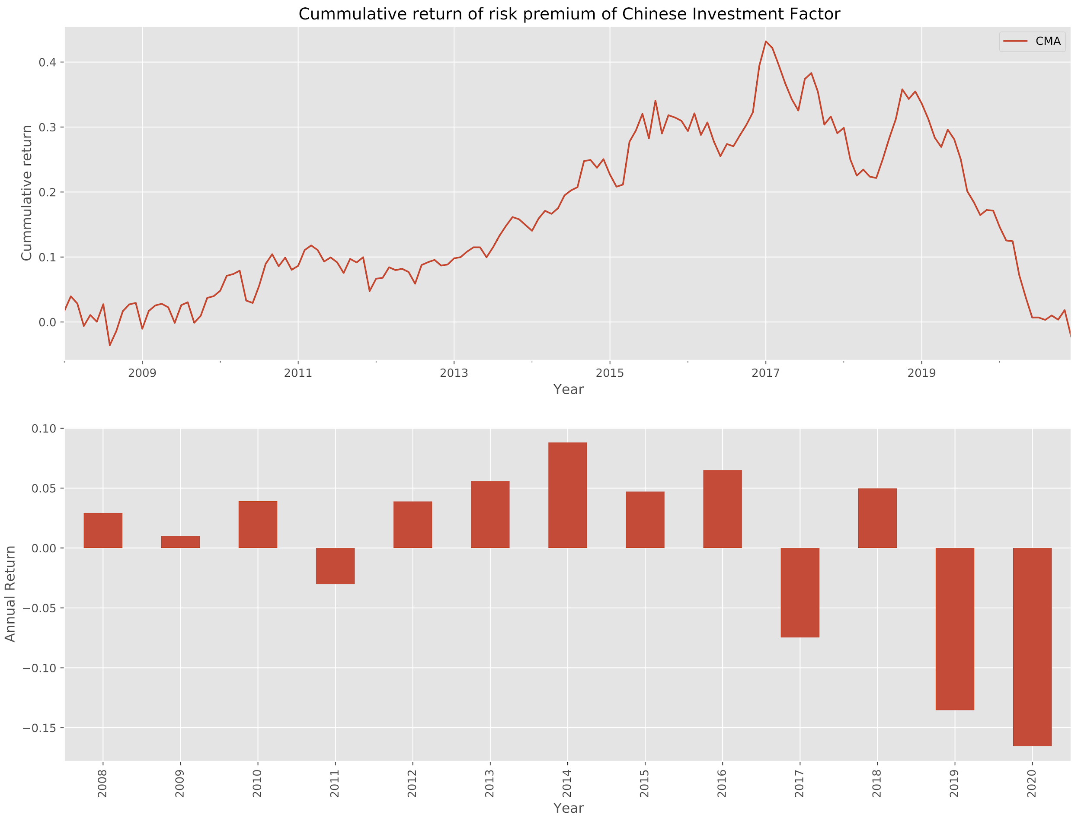

## **Visualization of table x for the Chinese market**

加图

## **Cumulative Excess Returns for single factor in US market**

## 

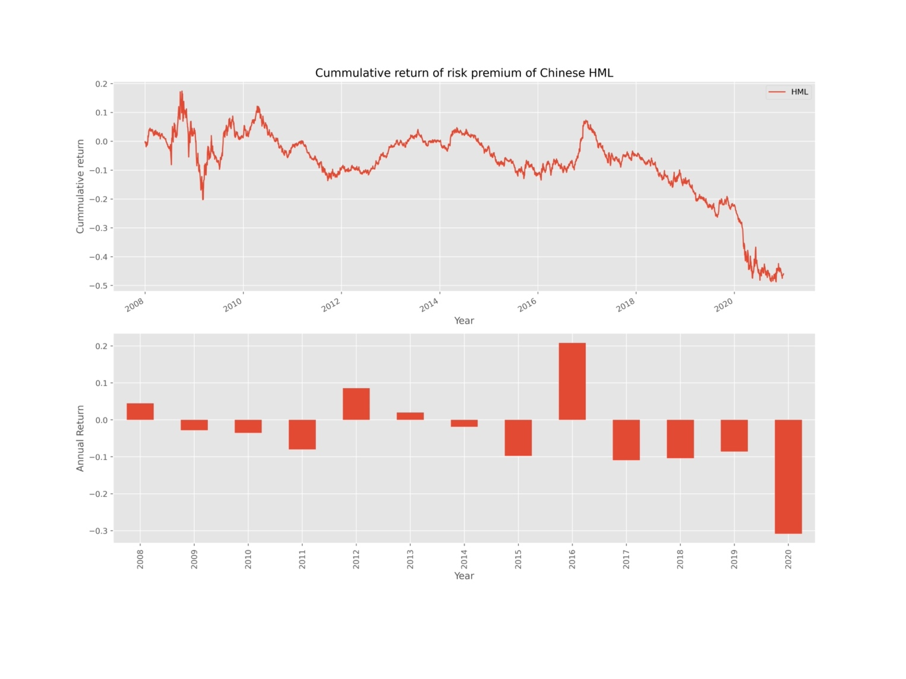

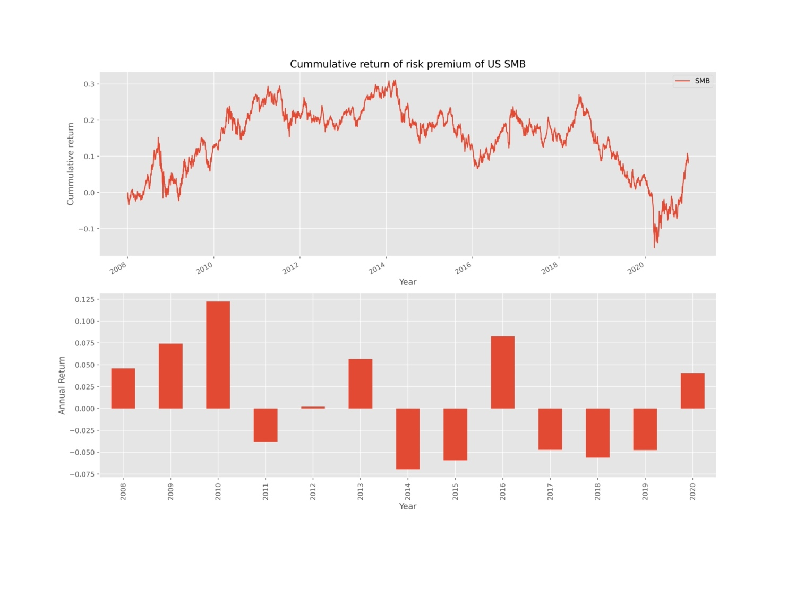

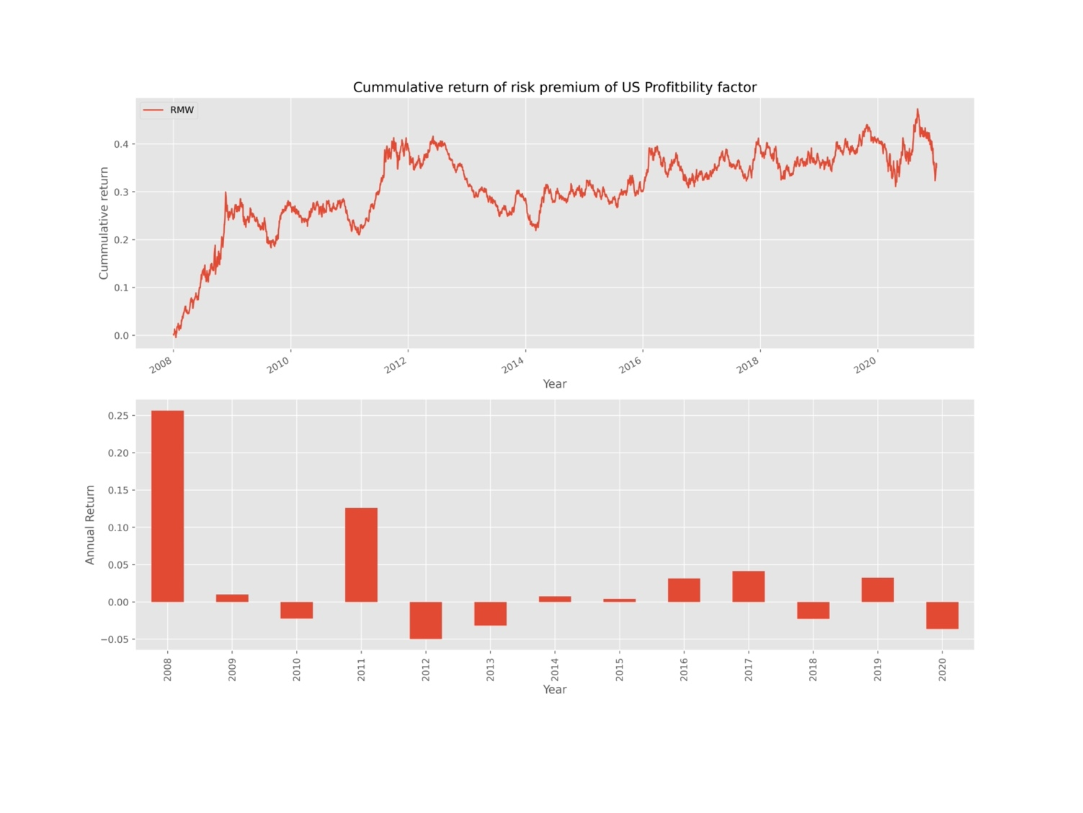

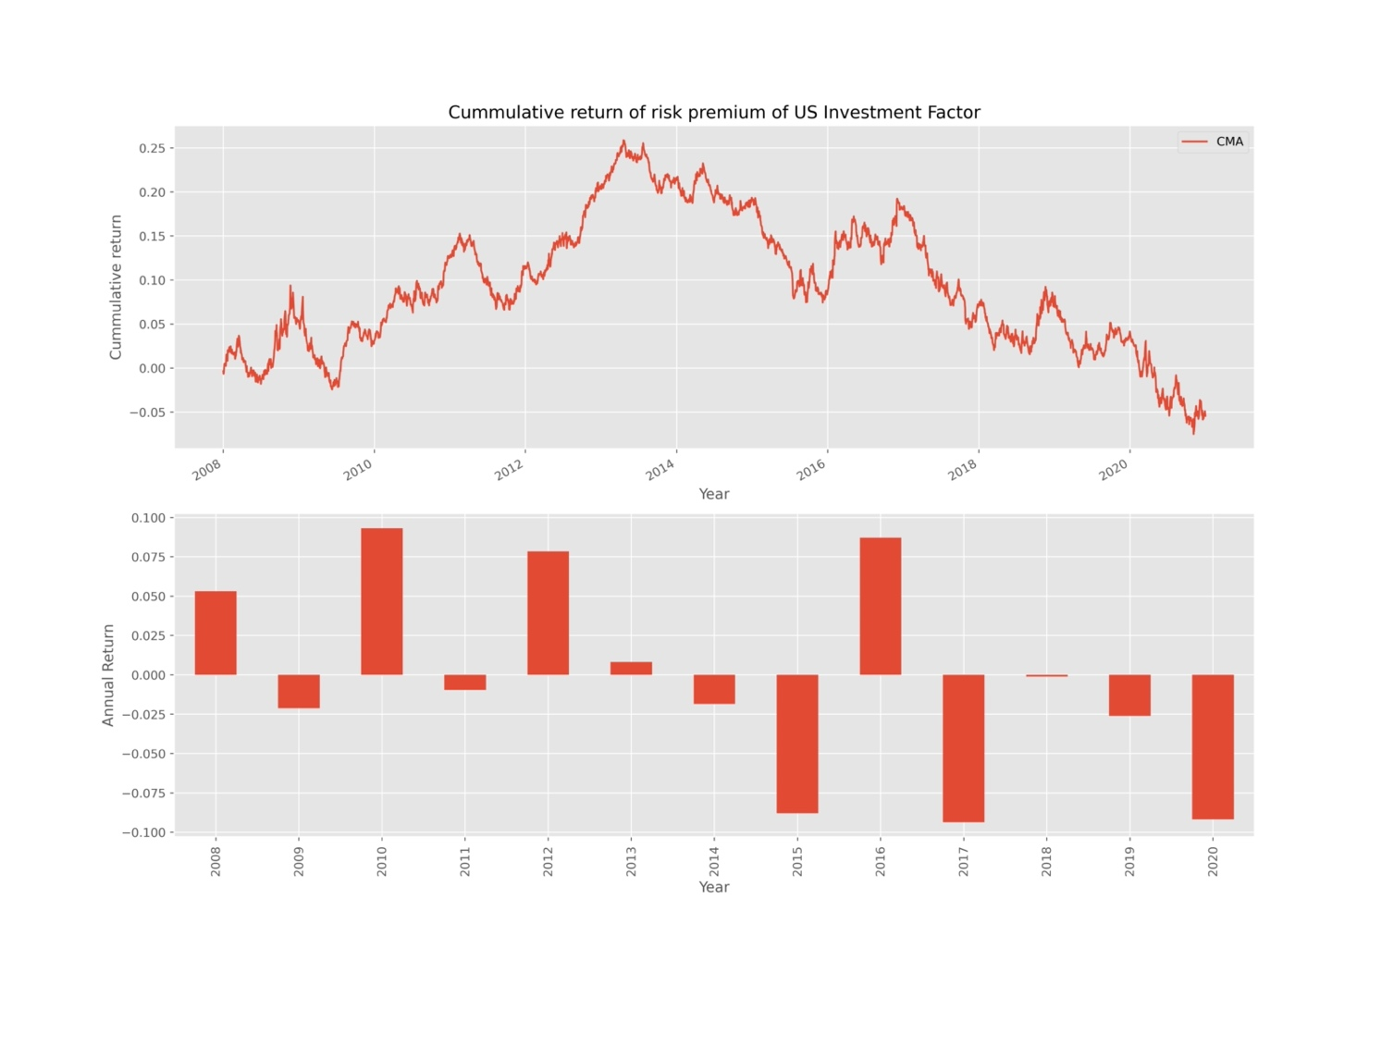

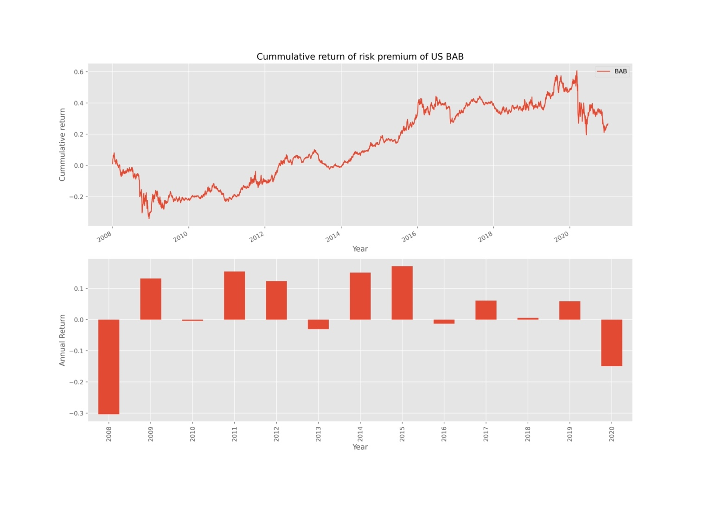

1. I.e., the market risk premium was smaller than what CAPM would predict
2. For the US Treasuries market, the BAB factor is defined as a portfolio that “holds leveraged low-beta (i.e., short-maturity) bonds and shortsells de-leveraged high-beta (i.e., long-term) bonds”, and a Sharpe ratio of 0.81 is generated
3. In credit markets, the portfolio of leveraged highly-rated corporate bonds generates higher return and Sharpe ratio comparing to a portfolio of de-leveraged low-rated bonds
4. In the original paper, the two hypotheses are defined as Proposition 1 and Proposition 2
5. As defined in the original paper and introduced earlier, a betting against beta (BAB) factor “is long leveraged low-beta assets and short high-beta assets”
6. For this project, we choose China’s A-share market as our focus and as the representative of the emerging markets
7. This market index is defined as “a value-weighted portfolio built each calendar period with all issues listed on NYSE/NYSE MKT/NASDAQ/Arca exchanges. Issues are weighted by their market capitalization at the end of the previous period”. (Center for Research in Security Prices, 2021)
8. AQR website: <https://www.aqr.com/Insights/Datasets/Betting-Against-Beta-Equity-Factors-Daily>
9. The same dataset is available from Ken French’s Data Library.
10. “In China, publicly-listed firms which are experiencing financial distress are required to use the prefix ‘ST’ in front of their trading stock code by the CSRC. The ST system was initiated to detect poorly-performing firms and therefore to release an early warning signal to both the firm and to investors”. (Zhou, Kim, Ma (2012), Survive Or Die? An Empirical Study on Chinese ST Firms)
11. The data is obtained from AsianBondsOnline.
12. For China’s A-share market, we use a slightly different number than 750 for non-missing data so that both the U.S. and China’s analysis can be done starting Jan 1st, 2008 (our raw data is available from the year of 2005).
13. The main report only includes the plots of BAB portfolio, market portfolio, SMB portfolio and profitability portfolio. The plots regarding the other two factors of the five-factor model are included in the appendix.
14. Calmar ratio is used to measure the risk-adjusted return. It is calculated as the compounded annual return versus the maximum drawdown. A higher Calmar ratio implies a better performance on a risk-adjusted basis during the time horizon